**Della’s Design Solution**

**CIS 3365**

Transition Technologies

Table of Contents

Executive Summary 3

Client Information 4

Benefits and Cost 5

Project Approach 6

Solution 7

Description of required forms and reports 8

Key decisions 47

Testing Process 49

Project Improvements 53

Project Database Maintenance Issues 55

Lessons Learned 57

Project Summary 59

References 60

Appendices 60

# 

# Executive Summary

Della Schapiro founded Della’s Design Solution on August 2015. She designs websites and graphic designs for clients based on client requests. The service costs are dependent on whether the client needs a website design or a graphic design.

Della Schapiro currently keeps track of her clients and project prices through tables on Microsoft Word and doesn’t have an application to input client information along with project and price details that can be adjusted accordingly across different tables. The current system used by Della’s Design Solution solely operates through manual creation and calculation and it has separate files and folders for clients’ information such as invoices and proposals.

The problems posed by the current system used by Della include inefficient quote process, inefficient data management process and inefficient calculating process, to mention but a few, hence the need for an automated system that can compile all the design business information into one application – a system that has the ability to track clients, projects, and rates. Furthermore, the application will be completely accessible by Della to make any changes to prices, projects, and clients.

As part of the data gathering aspect of this project, the team engaged Della in a live interview. The interview was centered on data storage and the processes clients will go through to purchase a web/graphic design service. The data gathered during the interview include documents, emails, past invoices, facts, history, and purpose of the business that Transition Technologies was building the application for.

A new system has been proposed to solve the problems Della’s Design Solutions is currently facing.  This system, after series of successful prototype testing, will take the fields Della has in her current system and integrate them with new data fields and tables for quoting, storage and invoicing. In the context of web designing to meet Della’s required strategic business needs, Transition Technologies has proposed a new system that can input client information and their project scope to help generate an invoice, break down the different options to a project to determine the service prices, keep track of hours, and calculate the deposit for projects. This new application will store all client information, the type of project requested, work type, additional services, hours, and be able to calculate various prices.

Two options were proposed for the system operation. The first option is to run the application off a Windows operating system and use Microsoft Access as a new system for Della’s Design Solutions. The major downside to this option is the additional cost (to the client - Della) of Microsoft Access and the fact that it could only be accessed locally. The second option is the proposal to develop and host the database for the application on Microsoft Azure. The developed application would be able to run on Microsoft Azure’s Cloud servers once complete and available as long as the service is available. This second option offers no additional cost to the client since Della’s Design Solutions has access to Microsoft Azure. This option will also allow for the full implementation of the entire proposed system from any computer hence is Transition Technologies’ preferred option.

Transition Technologies’ plans to complete the prototype’s final system test phase on schedule. The application, upon successful tests on multiple machines, will be delivered to Della’s Design Solutions together with the consumer user guide.

# Client Information

The client is Della Schapiro of Della’s Design Solutions and she keeps records of clients by adding and updating information to a Microsoft word document manually. She needs a database to store and search for projects and clients that are required. Our group Transition Technologies’ decided to create a new application for Della’s Design Solutions with features that will allow the input of client information and the project options to help generate invoices keep track of project prices and hours and break down the total price of the project with additional costs calculated. With the all the data, the deposit required on a project can be generated to help create a final invoice for the Della’s Design Solutions and the client.

The current system used by Della Schapiro consists of receiving email requests for projects then manually calculates options and related prices for data such as total prices, hours, and down payments onto the Microsoft word document. The options provided are the size of websites, the website type, graphic design size, and additional functions. The total price and deposit for each project is dependent on what options need to be created. Then a final copy is sent back to the consumer via email for project approval and initialization.

Through this new application, Della Schapiro needs to be able to break down services, track prices, calculate deposits, calculate markups, and generate forms. This application will be accessible through the internet and the application will run on SQL with a Java GUI front end. It should be able to login, input, output, and calculate the costs and requirements of each project according to what is requested. The client would like to be able to protect sensitive data with a login feature, the ability to browse through the project and make any changes or additions. The system should also be able to calculate the project cost and the resulting deposit.

Our sponsor Della Schapiro of Della’s Design Solutions has agreed to sponsor our group in creating this database for her business in order to make data input and output more efficient to both the client and user. Our group works closely with Della Schapiro in order to adjust the database to what she requires for her business.

# Benefits and Cost

The costs and benefits of switching Della’s Design Solutions from the current Microsoft word document system to a SQL database system would increase the productivity of both our client and users because of the reduced effort to track each project and client details. The total cost of ownership for Della Schapiro to keep the application running will include time and resources such as hardware, software, and additional setup and maintenance costs. Between the proposed system options for the database, it was decided that Microsoft Azure would be the most feasible platform.

The costs and time to create and install the application had been estimated and compared with other options to see the overall benefits and feasibility. Comparatively it was decided that creating the database on Microsoft Azure is estimated to be more expensive than creating the database on Microsoft Access, but overall offers more functions and is more suitable for possible future updates. The estimate for installation is approximately $640 with about 16 hours to set up for completion, the analysis and design will be about $2400 with 60 hours to complete, the GUI design will be about $1200 for 30 hours to complete, $400 to test the GUI for 10 hours, the build and design of the application will be about $1600 with about 40 hours to complete, the testing and debugging will be about $800 with 20 hour completion, the training of operators will be about $200 for 5 hours, $6750 for the transfer of existing data for 15 hours, and $400 to test and update the database for 10 hours. The total cost of ownership for Microsoft Azure is a total of about $14,390 and 208 hours to complete the implementation. Afterwards there will be a recurring fee to keep the system functional and online. These are all estimates and the costs and time of each objective can vary depending on the situation of the systems.

The decision to design the database on Microsoft Azure instead of Microsoft Access is because Microsoft Azure offers more usability and reliable features such as online access. The use of Microsoft Azure would allow the organization to create and access the application across different machines on the cloud. The downtime of the cloud is rare, so it would be available for most of the time with little maintenance.

There would be minimal training for the management and entry of data because there is no handling of technical side. The options and costs of the services provided will be calculated and an invoice can be generated from information provided by the application based on the additional markups and costs. The benefits of the application would increase the productivity of Della’s Design Solutions and the consumer compared to the current Microsoft word document system.

# Project Approach

The approach our group took for designing the database are results of the discussions of the activities that the team undertook to solve this client's database requirements.  This database design and implementation process that was took place during the semester.

**List of database design steps:**

1. Identify entities and attributes from business process
2. Establish correct relationships between tables
3. Identified primary and secondary keys
4. Addressed M:M relationships to ensure that there was an associative table
5. Created the data dictionary and identify the metadata

**List of database creation steps:**

1. Created the tables as it was presented in the ERD
2. Assigned primary keys and secondary keys to the tables
3. Created bulked data to load into the database
4. Loaded bulk data scripts to load the data into the database
5. Created user defined functions and queries
6. Ensured that cascade update and delete was included

**List of GUI creation steps:**

1. Linked the database to the Java application
2. Created database forms
3. Created login screen
4. Created report functionality for different reports reports

**List of testing steps:**

1. Tested the data in the SQL database by running queries and the user functions
2. Validated relationships in the ERD and Database design
3. Addressed bugs in our SQL code
4. Verified the connection between the Java application and SQL database
5. Loaded the database multiple time to ensure that the scripts had no bugs
6. Tested all the forms in the GUI to ensure input and output of the data
7. Formatted the bulk data as needed in order to load into the database
8. Compiled the create, alter, bulk insert scripts, and sample data files
9. Verified for referential integrity

**List of implementation steps:**

1. Implement system in business
2. Checked for system compatibility
3. Installed software and database for the client
4. Hold training sessions in groups for users and managers
5. Monitored the performance of the database
6. Performed updates for the systems to ensure that they were up to data with patches

**List of maintenance steps:**

1. Scheduled automated full database backups
2. Scheduled database clean up
3. Scheduled incremental backups
4. Scheduled updates for the database

# 

# Solution

The database designed this semester, was simplified to what was orginally, needed versus wants. Last semester when talking with our client, we discovered everything was manually done.  From back forth emails about contract of what is going to be done, invoices being sent, and generating client interest. Della also specified that she wanted a way to track cost, calculate deposit and markup, generate forms, break down services offered, and track cost. What we did to meet the necessary requirements was create a simplified database from 40 plus tables to fewer than 20 tables in SQL Server 2017 and linked database to a Java application.

On the Java application we first created a login page for our client to access database and get information from database.  Whatever query is ran, it will show the result as a table in the application below the text box.

While developing the database, we decided to come up with three tables that would make things easier for Della.  First, we decided to create a TempClient entity that would store client info who have inquired about Della’s services.  If no response is made from them within a week, their information will be deleted automatically. However, if a client decides to further pursue Della services, the information stored in TempClient will be saved for future reference.  This will help differentiate interest from customers. Second, we added a Balance table that would record any unpaid balance (deposit) from Della’s customers and be removed when paid. When the balance is paid, the information goes to PaidToDate table which records when payments were made to Della.  In order for Della to track cost, we implemented a Requirements table that holds information regarding programs used to track cost of those programs as well as added expenses. Lastly, we created a Service table which records description of service, service date, Clientid, WebsiteJobid, and GraphicDesignJobid to track past services. Additionally, the WebmasterLogin associates the Client to a username and password.

In the early stages of the project we were troubled with 40 plus tables.  As some tables, functionality wise, were necessary but weren’t mission critical gave us the hardship of trying to figure out how reduce the size of tables to no more than 20.  Once we broke the tables down to the core we were than able to determine and bring back certain tables that made sense functionality wise in the database. We also realized that not all objectives discussed last semester were going to be met due to time constraints this semester.

## Description of required forms and reports

**ClientAddress**

ClientAddress query results all addresses associated with clients.  Reason why our client would want to use this is to specify a certain address for a client.

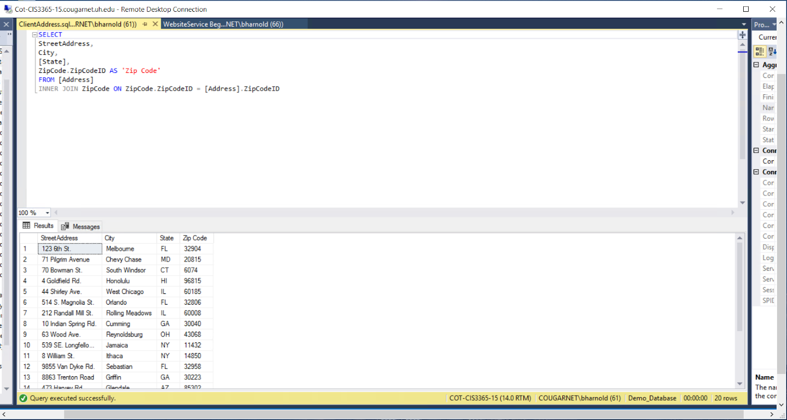

**ClientLogin**

ClientLogin results in matching the domain with the specific username and password of the client.  This will allow Della to relate her clients to their domain with login credentials.

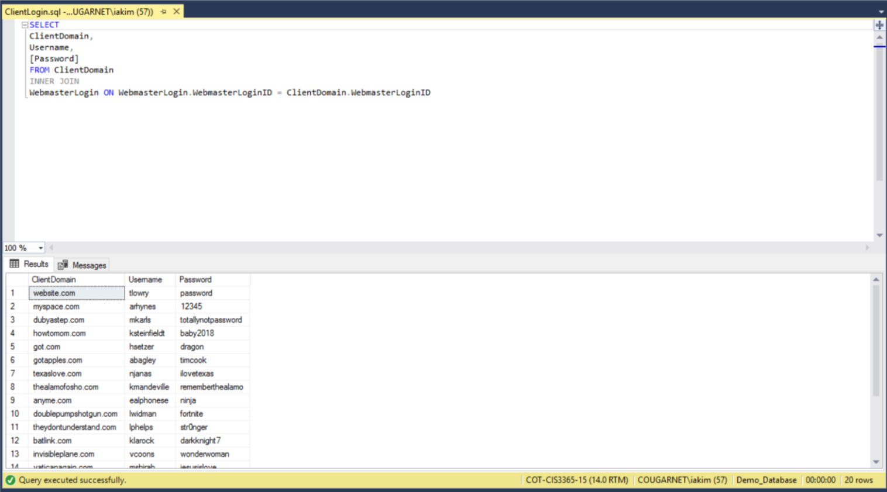

**ClientPhone**

Associates area code with phone number.  Della can use this query to find area code of given phone number to contact her clients.

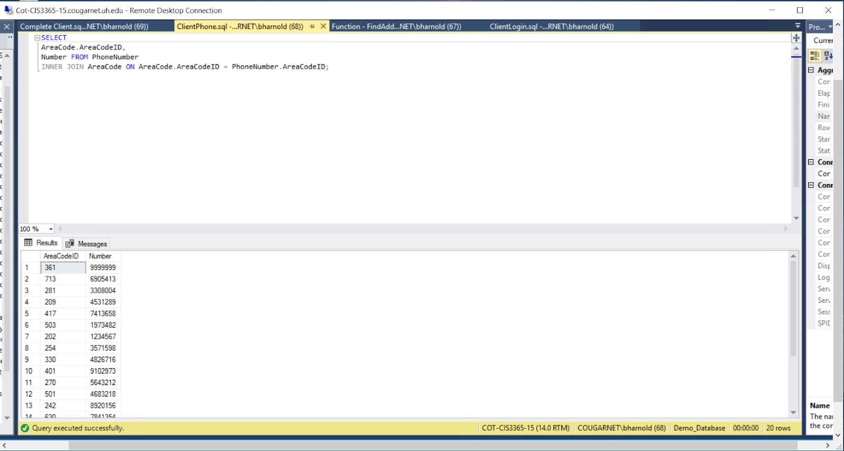

**Complete Client**

Results in all client information being shown.  Decifiers between a temp client and actual client as well list all information associated with that client.  She can use this query to see how many clients she has as well as potential clients.

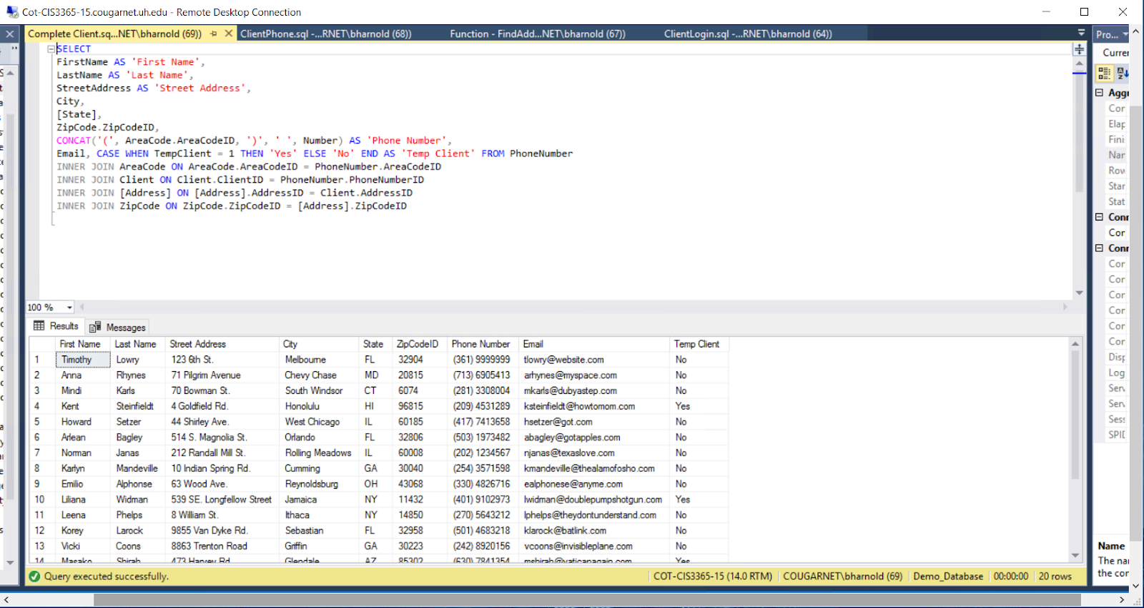

**Function - FindAddon**

This query results in filtering services done by description and addon.  Shows price of the addon and how many times that addon has been done for the description.

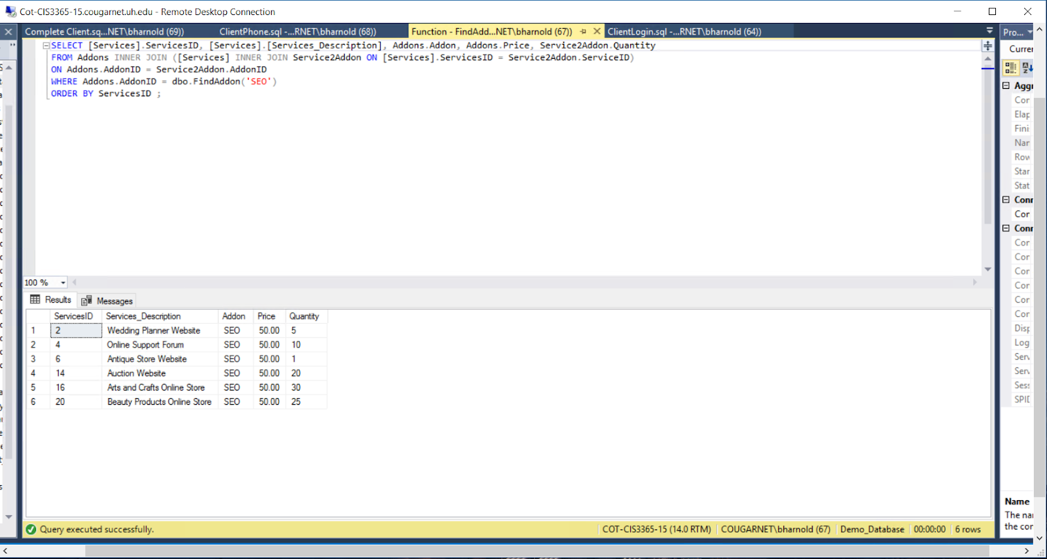

**Function - FindDomain**

Filters domain with login credentials based on domain of choice.  Della can use this to find a specific domain for a certain client.

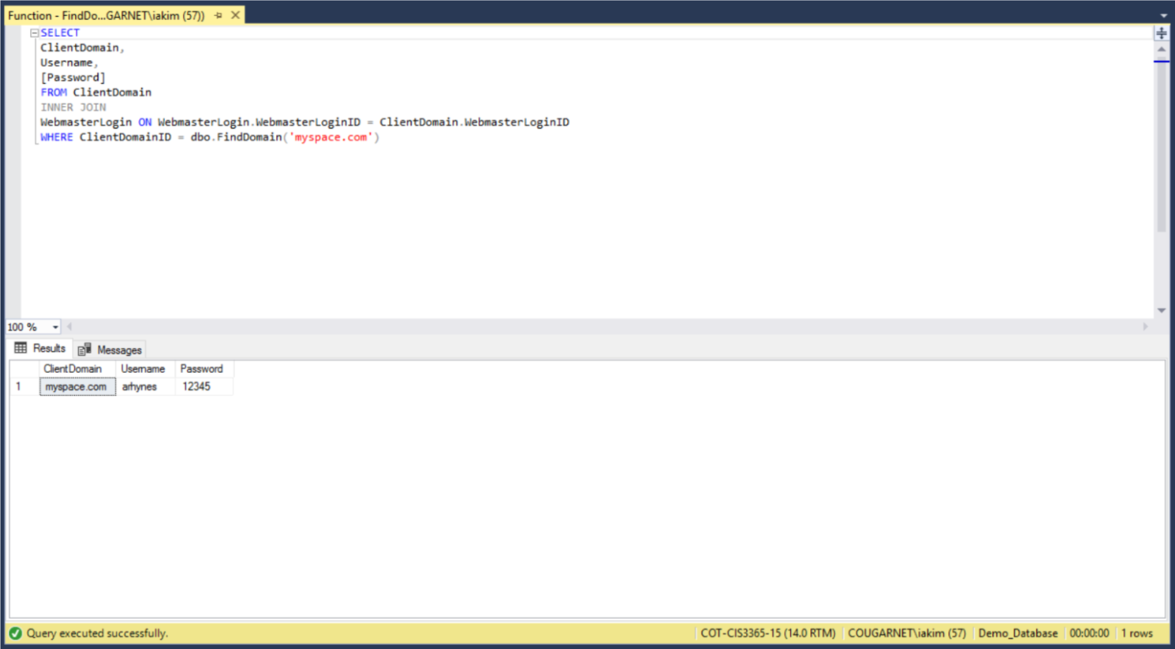

**GraphicDesignService Beginning**

This query results association between client information, services, balance, and paid.  Based off of client information, it will result in the description of the service, job type, balance, paid, and when the service took place. Della can use this query to see past services she has done.

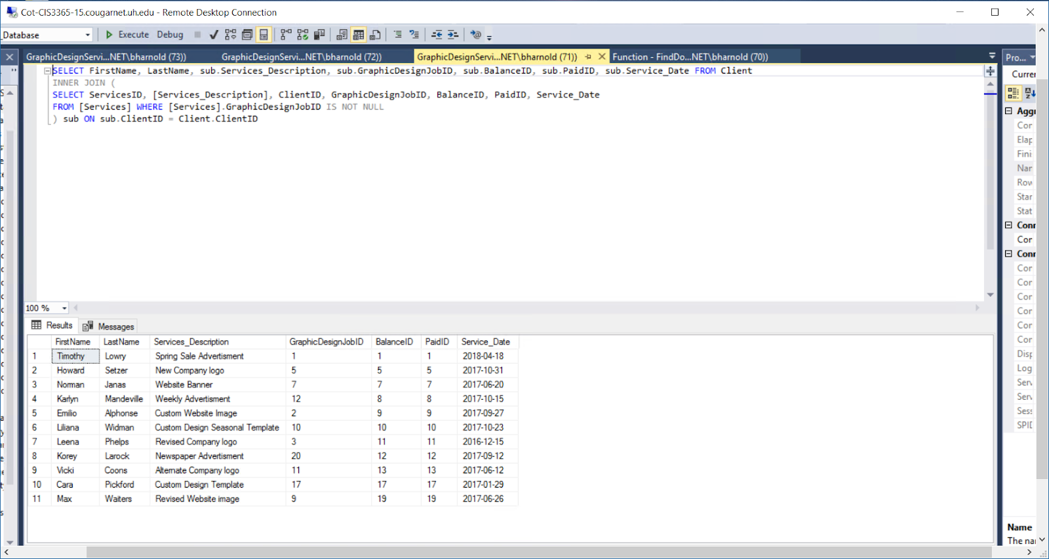

**GraphicDesignService DONE**

This query results in all client information associated with service provided, job description, balance, deposit, paid, and whether they are a temp client or not.  Using this query will allow Della to explicitly see how much is due from that client, the amount of deposit, and how has been paid. Because it is linked to services she will also be able to see when the service started and whether or not they are a potential client.

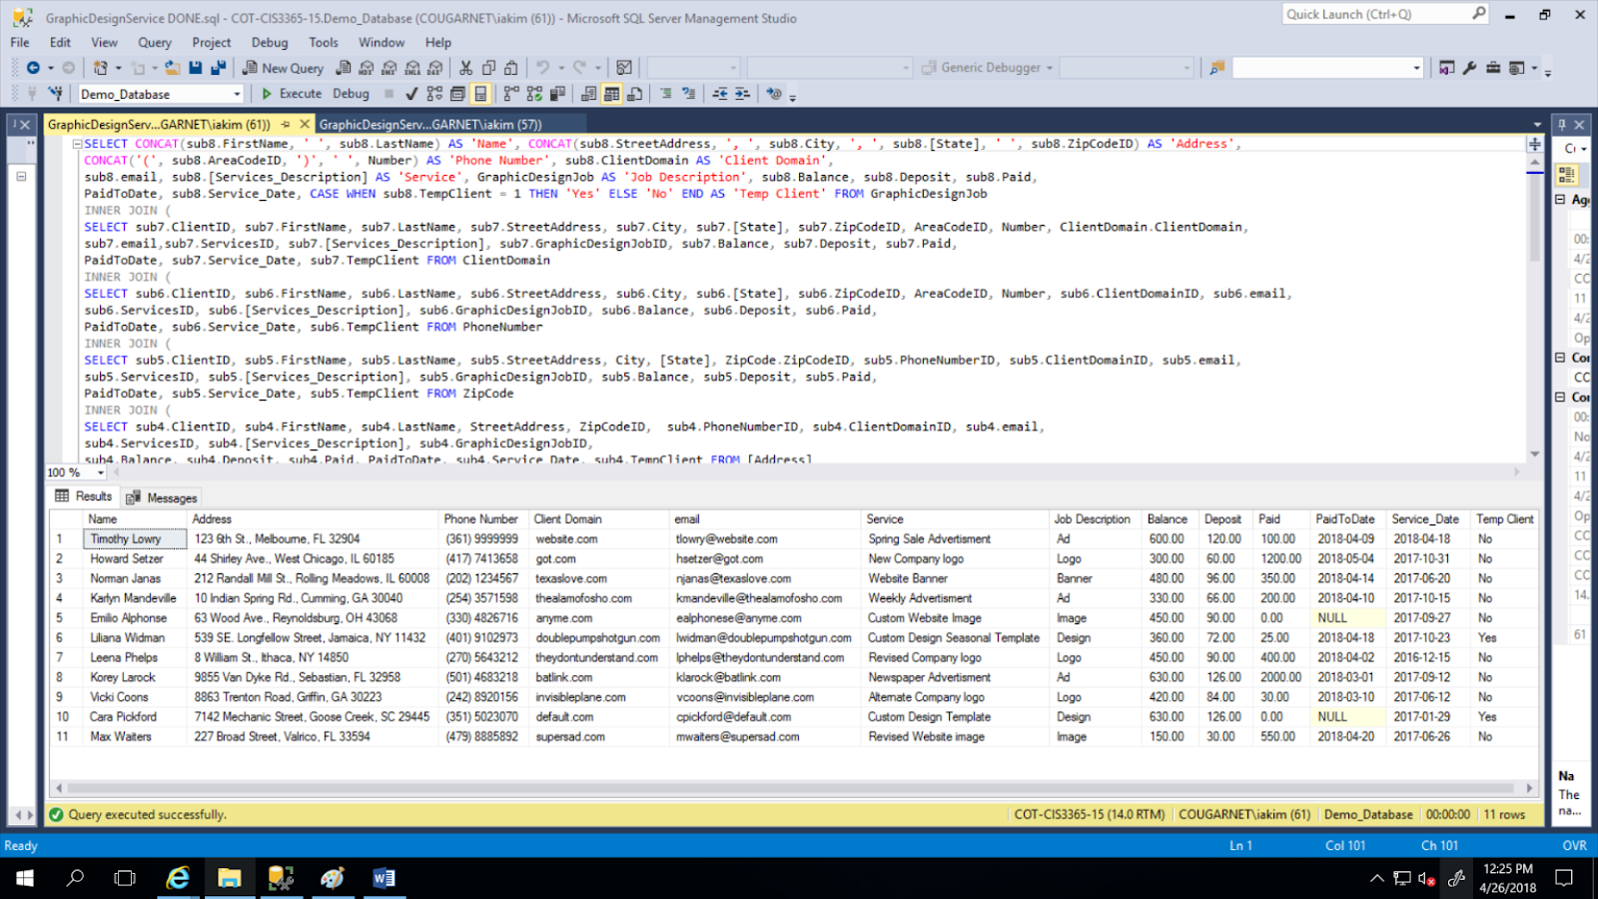

**GraphicDesignService with BALANCE AND PAID**

This query shows when the client made a payment towards a balance and when the service began.  Della can use this to determine which clients have paid either deposit or full amount towards balance in association with service date to paid date.

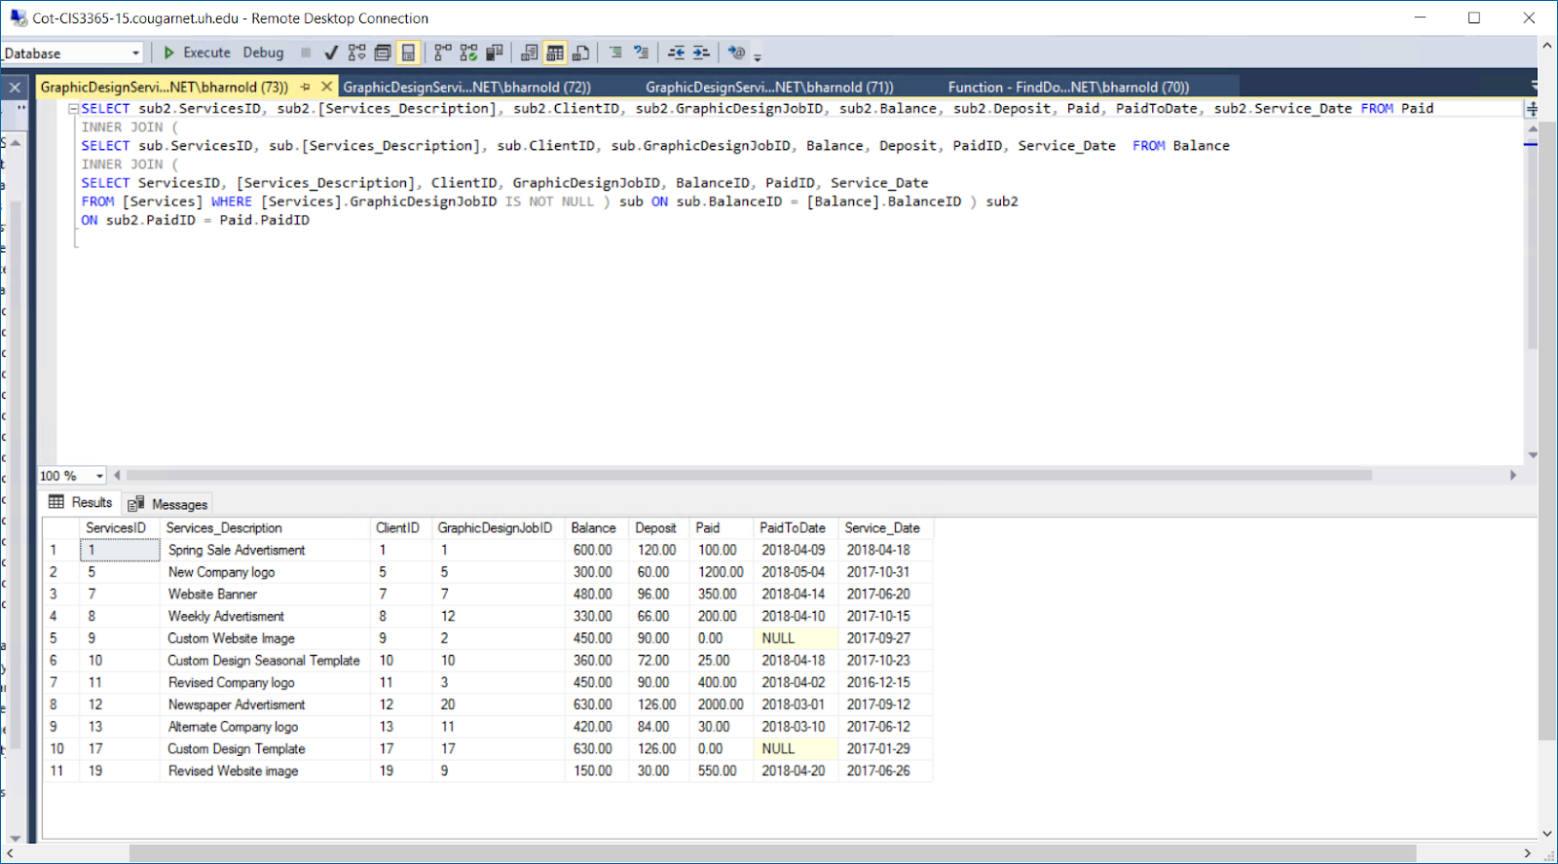

**GraphicDesignServices with Partial Client and Complete Address and Complete Phone Number and Domain**

The query results in client information being associated with services, their domain, balance, deposit, amount paid, and dates associated with the service and paid amounts towards balance.  Della can use this query to see all details about client and services (payments, dates, domain, etc.).

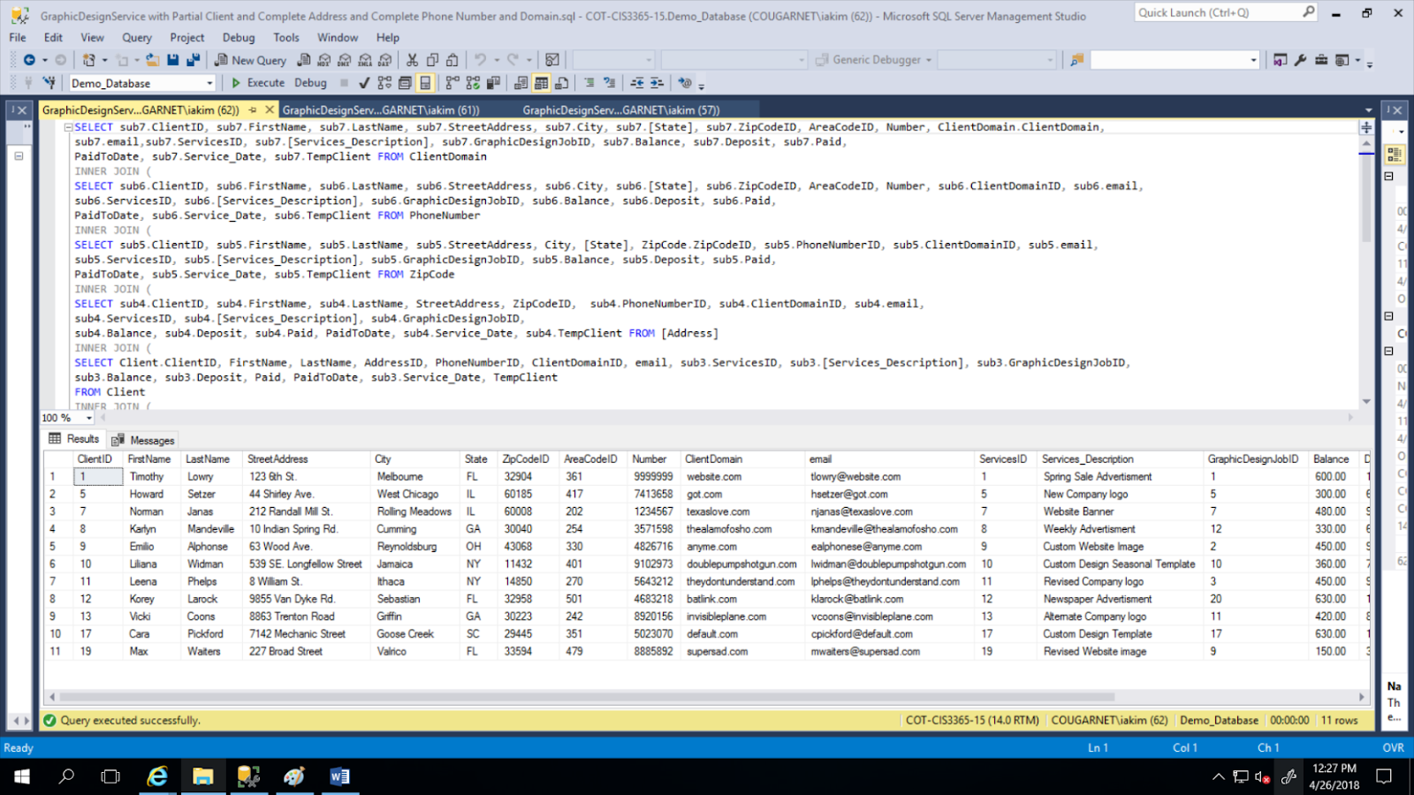

**GraphicDesignService w/ Partial Client, Complete Address, Complete Phone Number**

This query takes the client information and associates it with services, their domainID, graphic design job id, balance, deposit, paid, and dates tables.  This simplifies the previous query by simply applying a filter to less information and associating more ID’s.

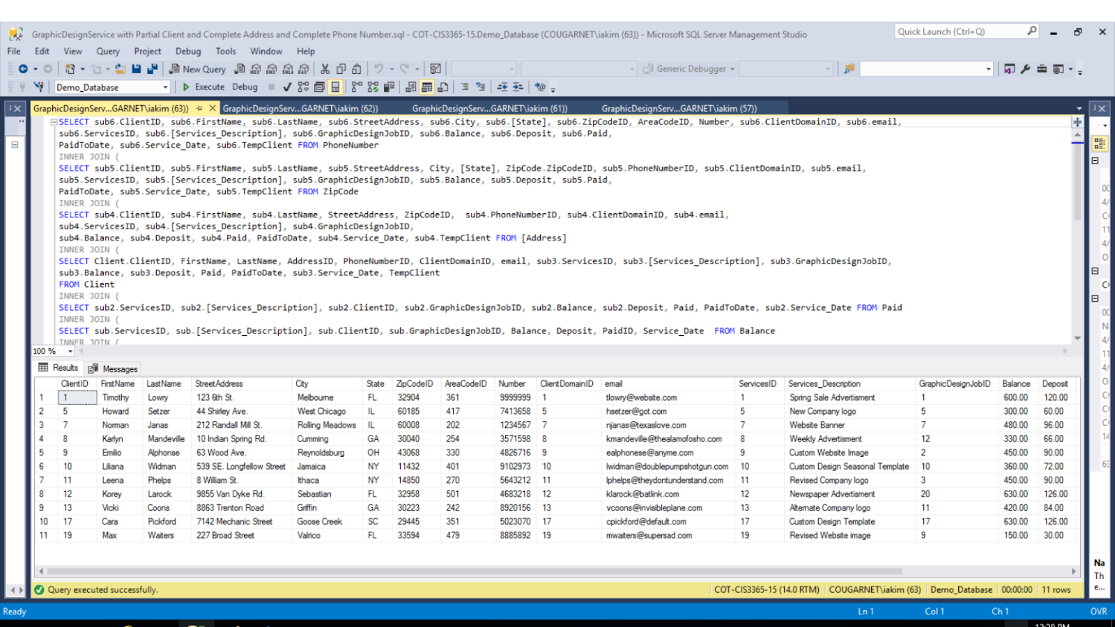

**GraphicDesignService w/ Partial Client, Complete Address**

This query results in the client information associated with the graphic design and service ID type Della has done for them.  Della can use this to filter clients with the service she has done for them in the past.

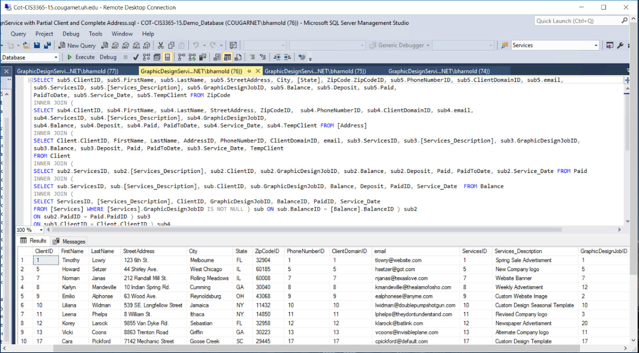

**GraphicDesignService w/ Partial Client, Partial Address**

This query results in client information associated with just IDs: client domain, phone number, services, and graphic design. Also associates balance, deposit, and paid amounts.  Della can use this query to see who has to pay for their requested service by Della or who has paid in total for their service.

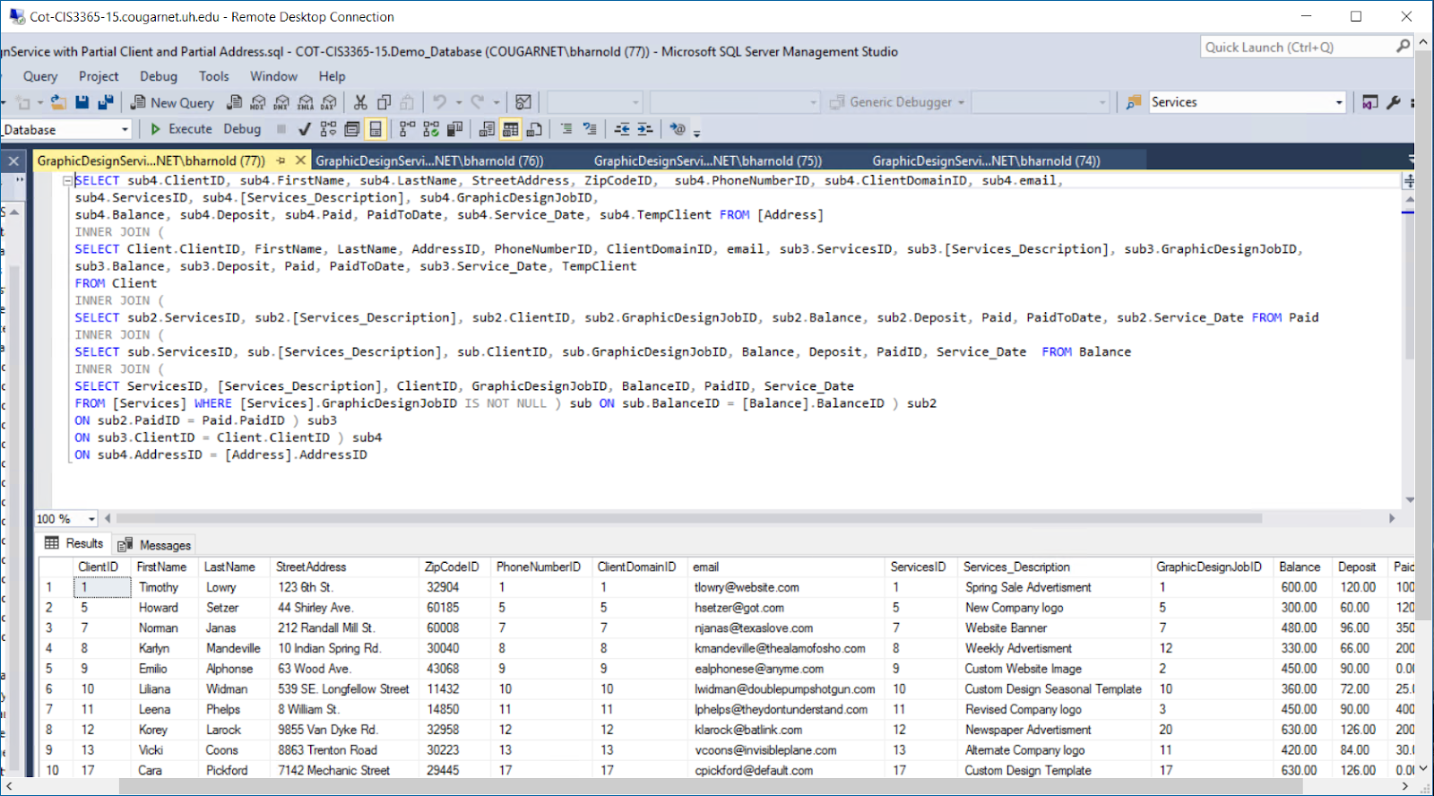

GraphicDesignService w/ Partial Client

Results in client first and last name associated with the IDs of everything else.  Purpose of this query is providing less information and give Della only the information she needs.

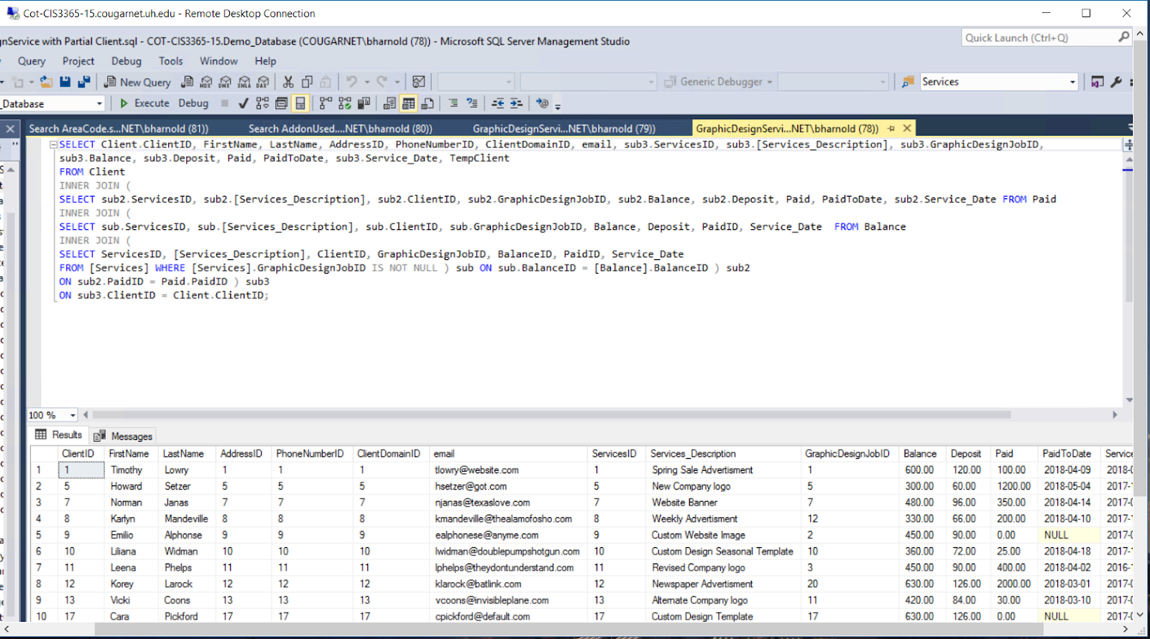

**GraphicDesignService**

Resulting query shows the service associated with the client based on graphic design job and how many hours it took to complete. Della can use this to calculate her price to charge her clients for the graphic design job.

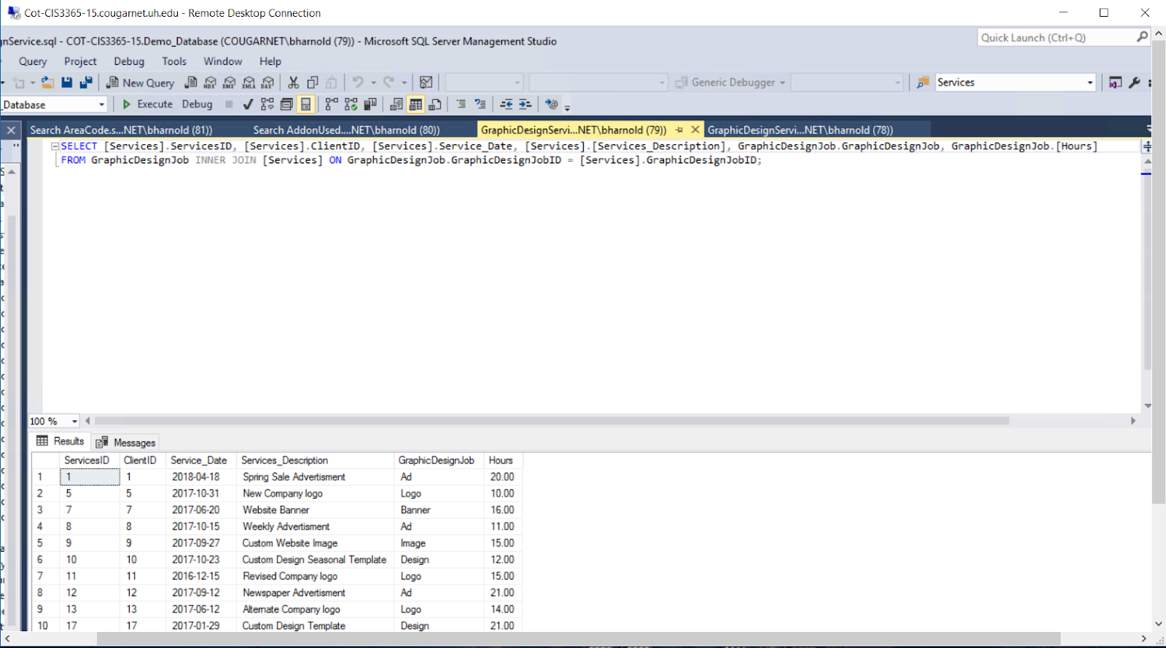

**Search AddonUsed**

Query results in the service done with the specified addon and how many times the addon has been for the specific service.  Della can use this query to show how many times she has used that addon feature.

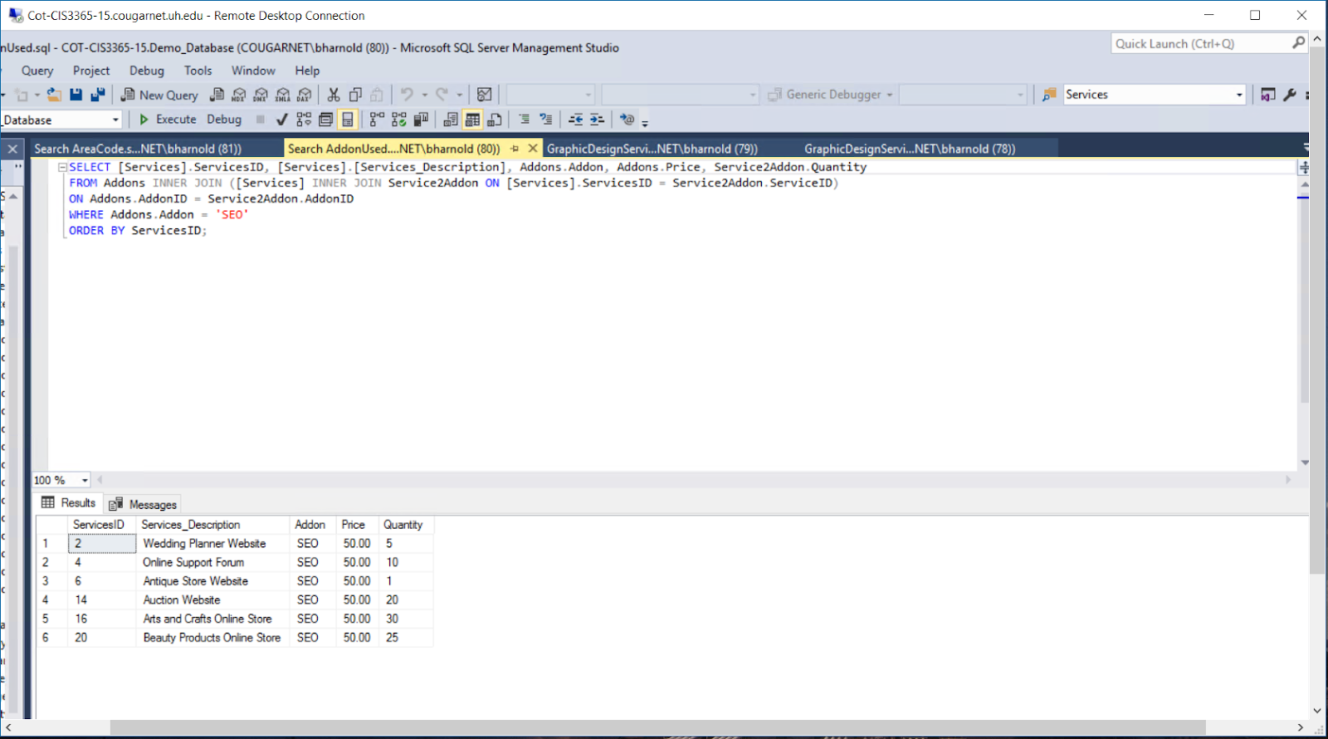

**Search AreaCode**

Query results in the search of which area code belongs to which state.  Della can use this as partial information to figure out where her clients could potentially be from.

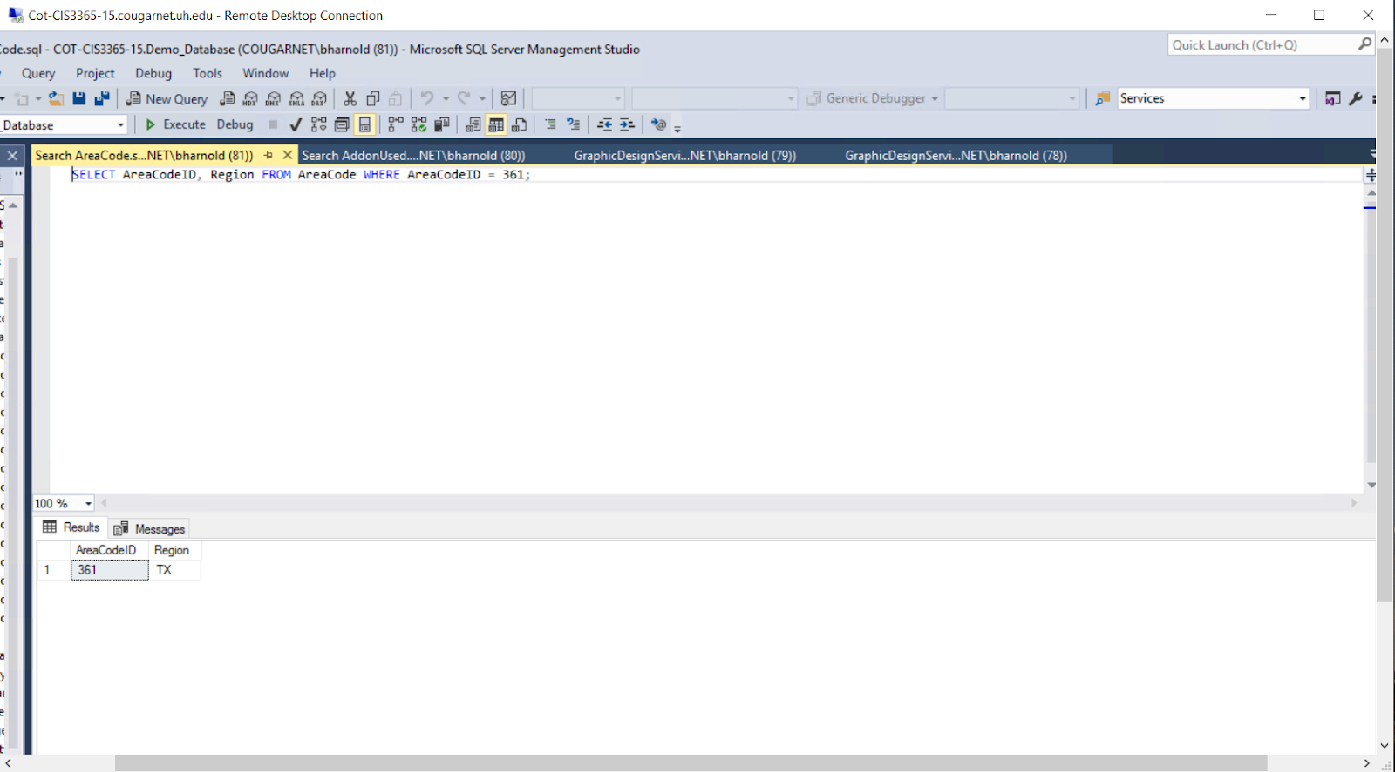

**Search Client**

Results in the specific search for a client based on first name.  Rather than going through a list, Della can use this query to filter clients based on a letter of the first name or first name in total.

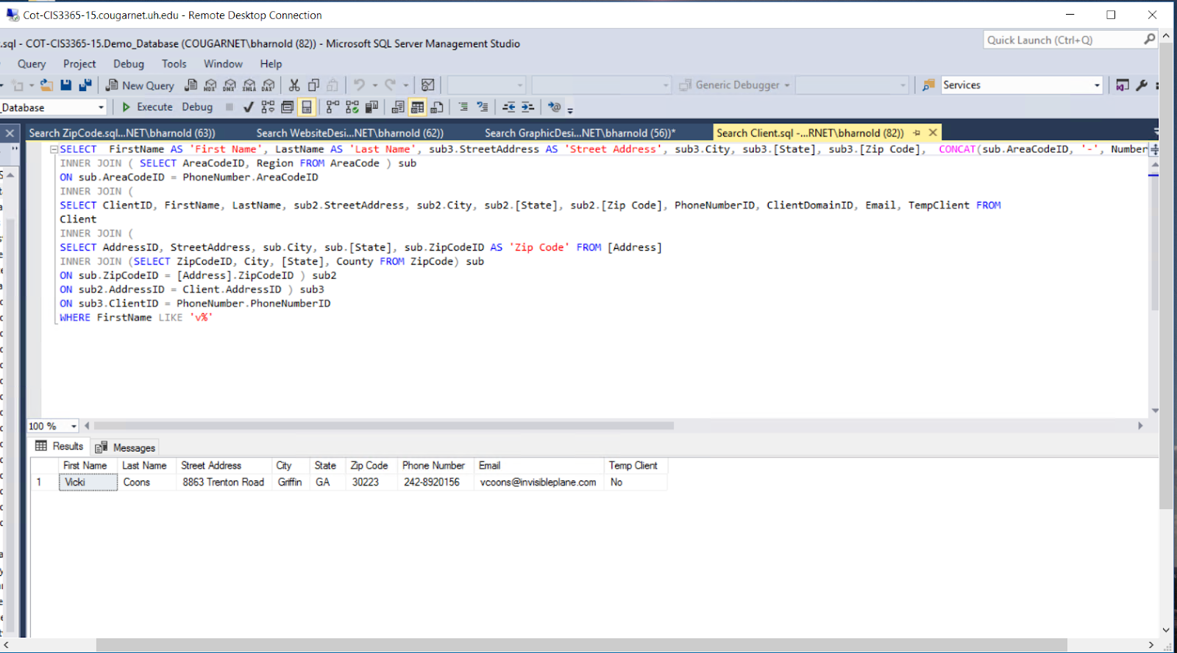

**Search GraphicDesignService**

This query filters the first and last name of the client and what graphic design service was completed for them.  Also shows the balance, deposit, amount paid towards balance and dates of when payment was made and services done.  Della can use this to find the information of a past service to a specific client.

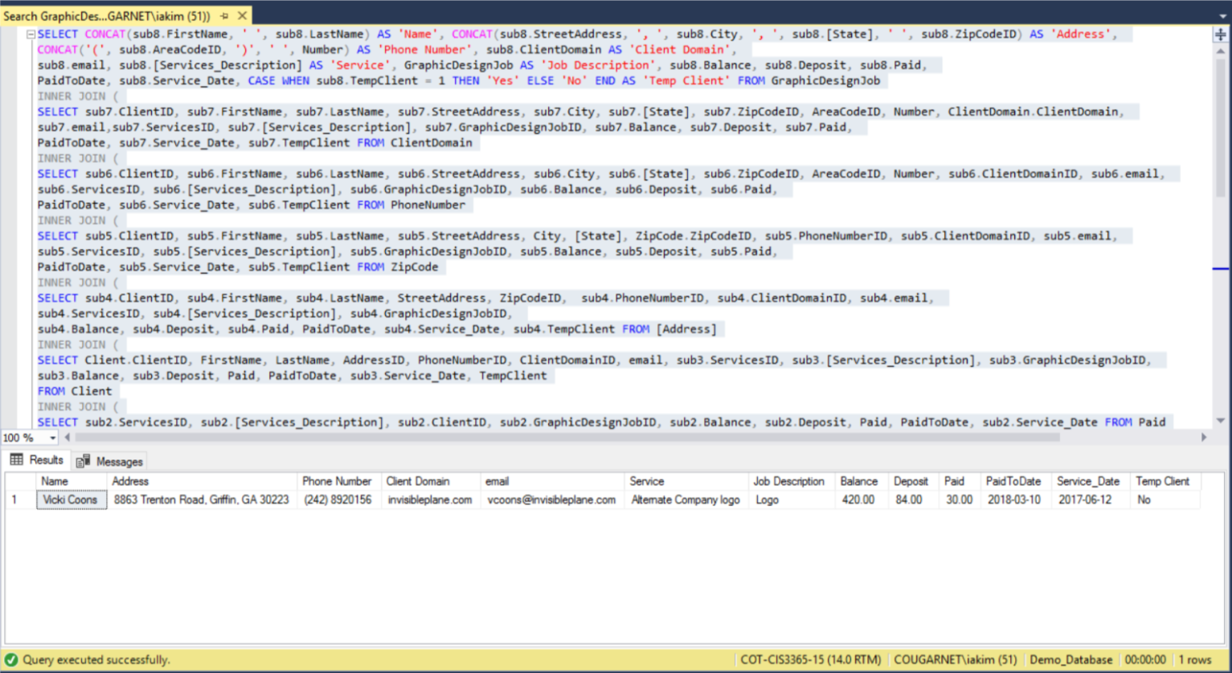

**Search WebsiteDesignService**

Same result as Search Graphic Design except filters for website design jobs to clients.  Della would first determine the client she is looking for than results in the website design service she completed for that specific client.

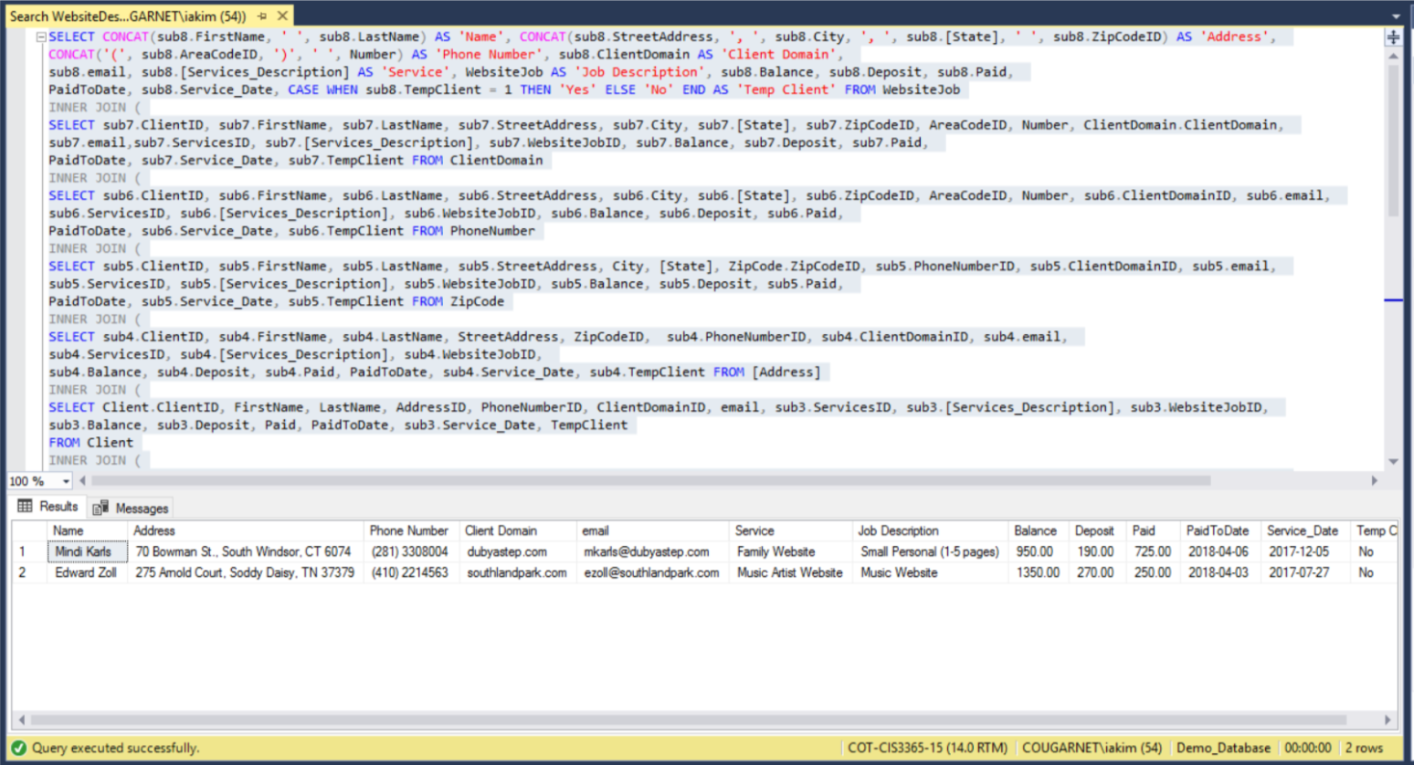

**WebsiteService with Partial Client.sql**

This query report shows the website service with the partial client. Since one of Della’s Design requirements was to be able to pull up the client and be able to match it to the website service that the client has currently requested. This report will help Della’s Design meet this requirement by being able to run a report that will pull up the data of the client and service by ID. It will also show the client first name, last name, and phone number. When it comes to the service, it will match it to the client ID and she will be able to see the service description and the balance that the client owes.

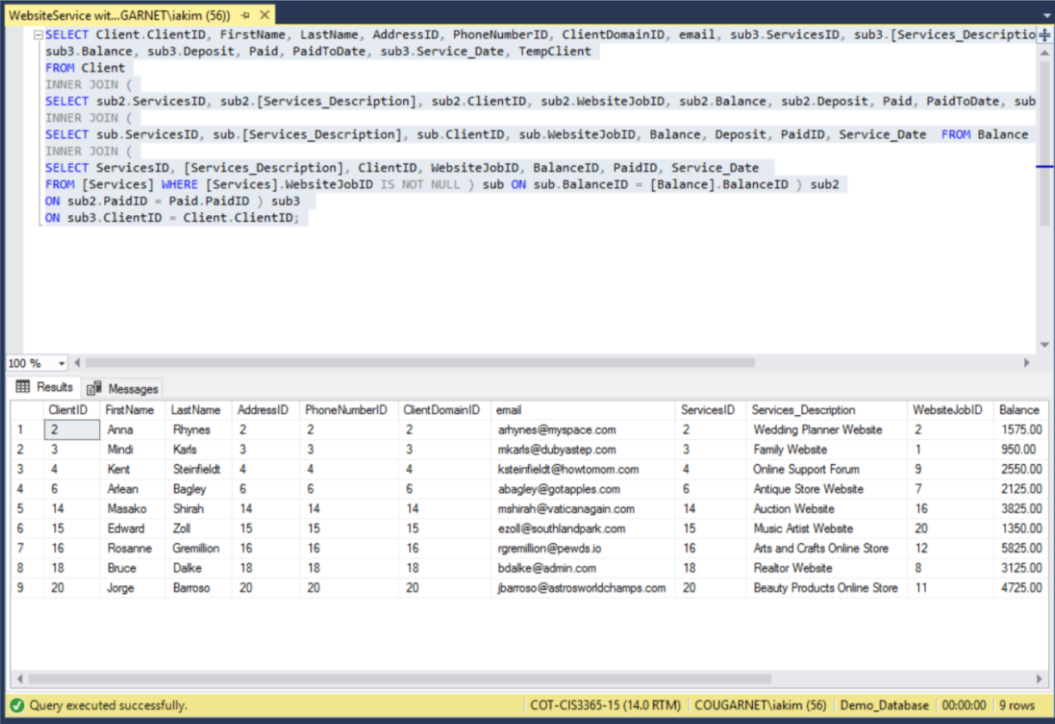

**WebsiteService with Partial Client and Partial Address.sql**

This query report shows the website service with the partial cient and the partial address. Della’s Design likes t sometimes just search partial parts for the cline and the address to make it a short list. In this report only the first name, last name, street address, and zip code are generated which gives her a shorter description for customer information which will fulfill this requirement that she has asked to complete.

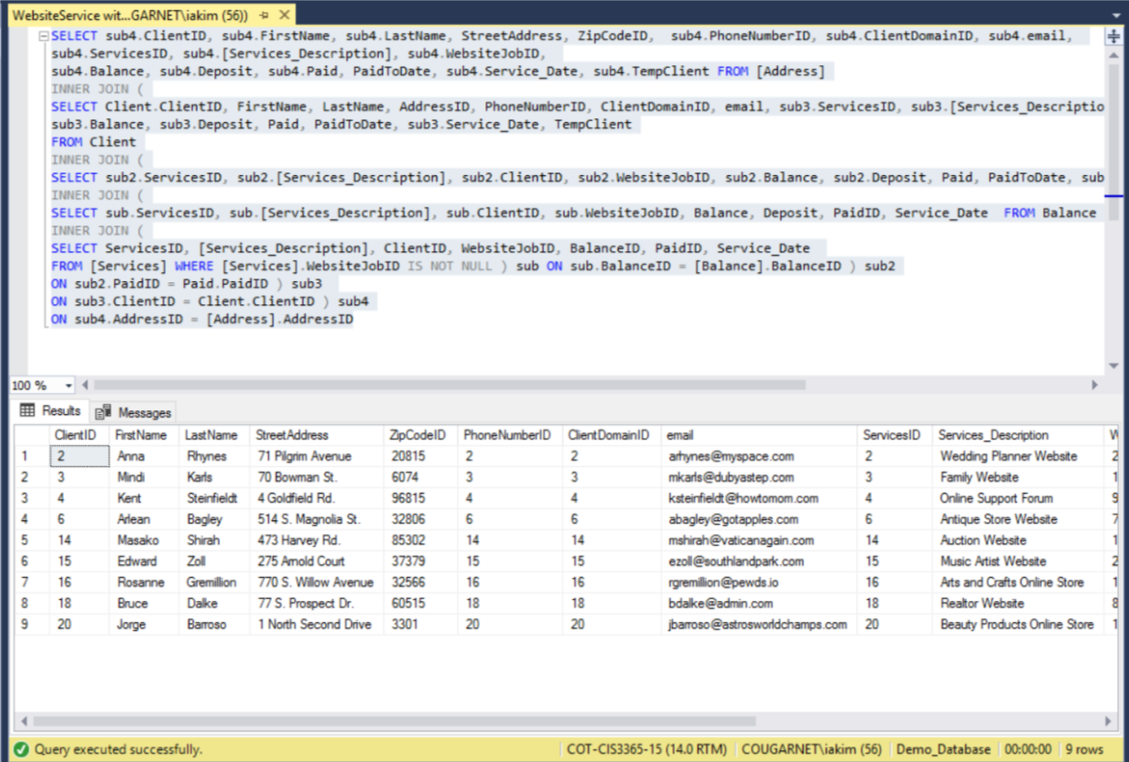

**WebsiteServiceWithAddon – Quantity Calculated.sql**

This query report shows the Website Service with add on with the quantity calculated. Della’s designed currently writes people add on requests on paper and the calculated the total user a calculator and writes it back in which is time consuming and is not able to tell customer their total right away. This report will help her get rid of that issue by allowing her to run a report of the addons and it will give her to total of certain addons that have been added by customers.

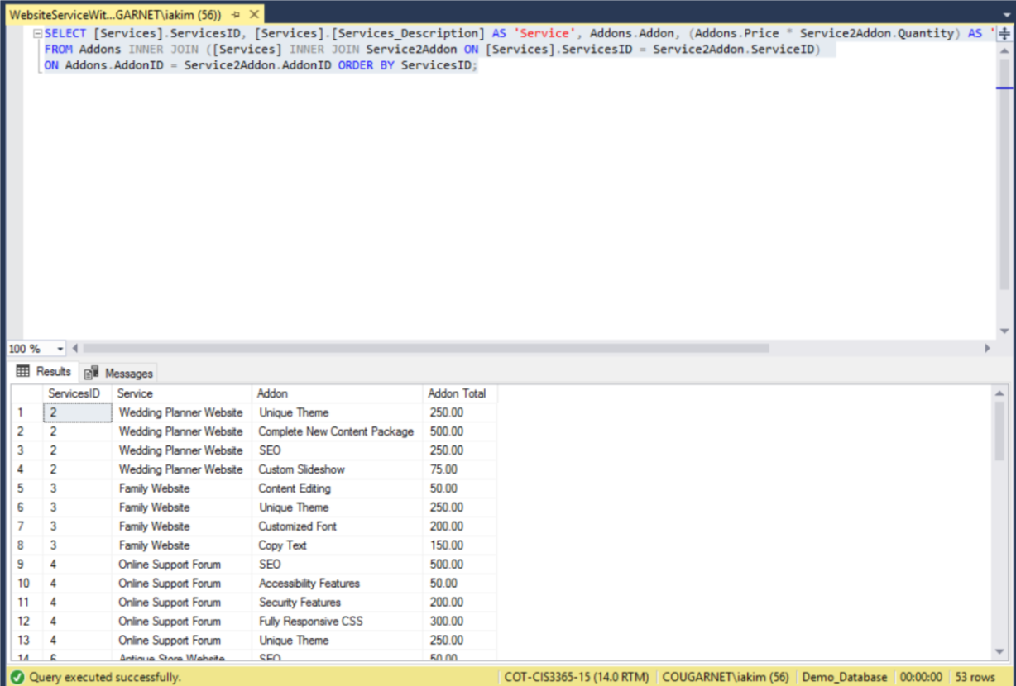

**WebsiteServiceWithAddon – Totaled.sql**

This query report shows the Website Service with add on with the quantity calculated. Della’s designed currently writes people add on requests on paper and the calculated the total user a calculator and writes it back in which is time consuming and is not able to tell customer their total right away. This report will help her get rid of that issue but allowing her to run a report of the addons and it will not only give her total of the addons that have been added by the customer but it will also give her a total of the addons.

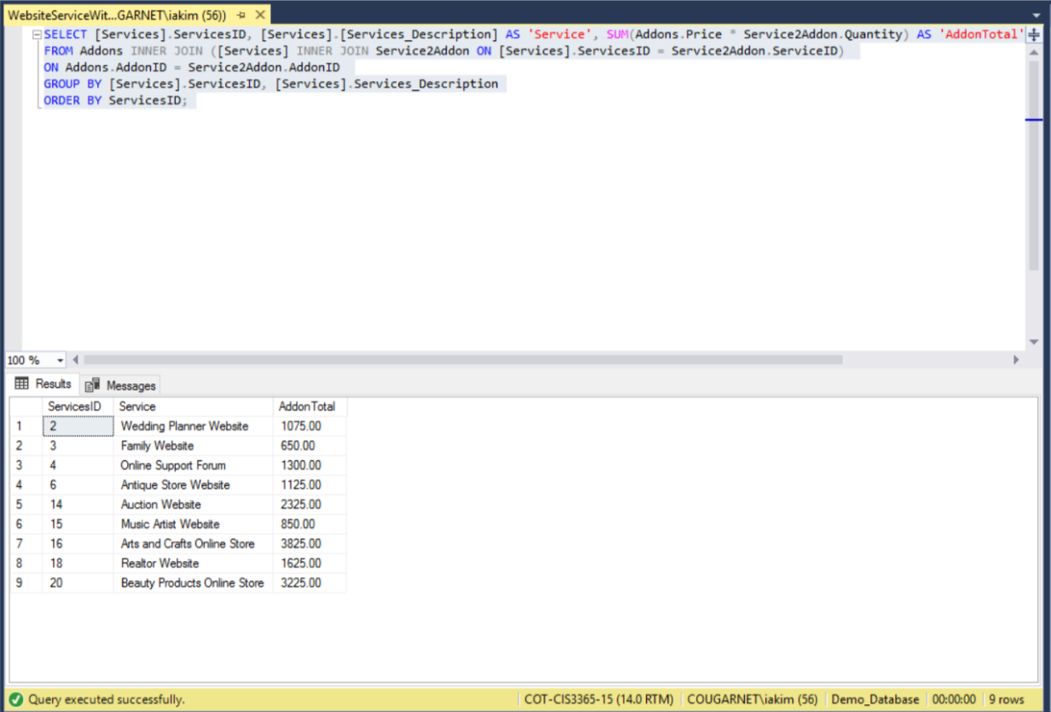

**WebsiteServiceWithAddon.sql**

This query report takes the addon price with the quantity of addons that a client desires and multiplies it, it is then stored in “AddonTotal”. When this report is ran it will output the Service ID, name of the service, and it will give the total of the addon.  Della’s Design currently does not have a way to keep track of addons that are added to services in an organized way that will help her keep track and give an accurate total to the client. This report will satisfy her requirement to be able to keep track of what addons are being added added to which outstanding orders and the prices to be able to invoice the client.

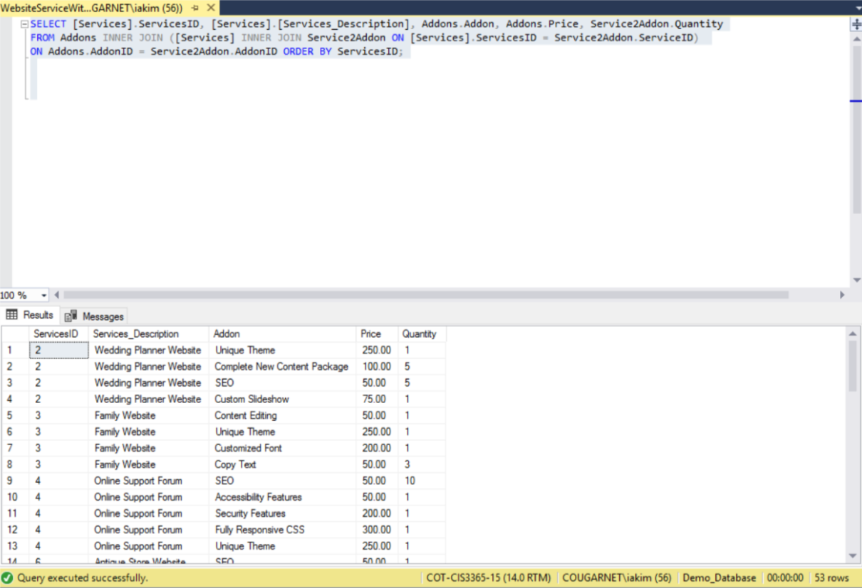

WebsiteService with Partial Client and Complete Address.sql

This query reports represents the website service with the partial client and the complete address for that specific client. Currently Della’s Design keeps all her customer data in paper which are stored in file cabinets and every time she wants to access this information she has to go through tons of papers to get to the specific client that she is looking for. This report will help Della’s design be able to pull a report of all the current clients that services are being provided to and she will be able to tell the clients first name, last name, and address as well as the email address.

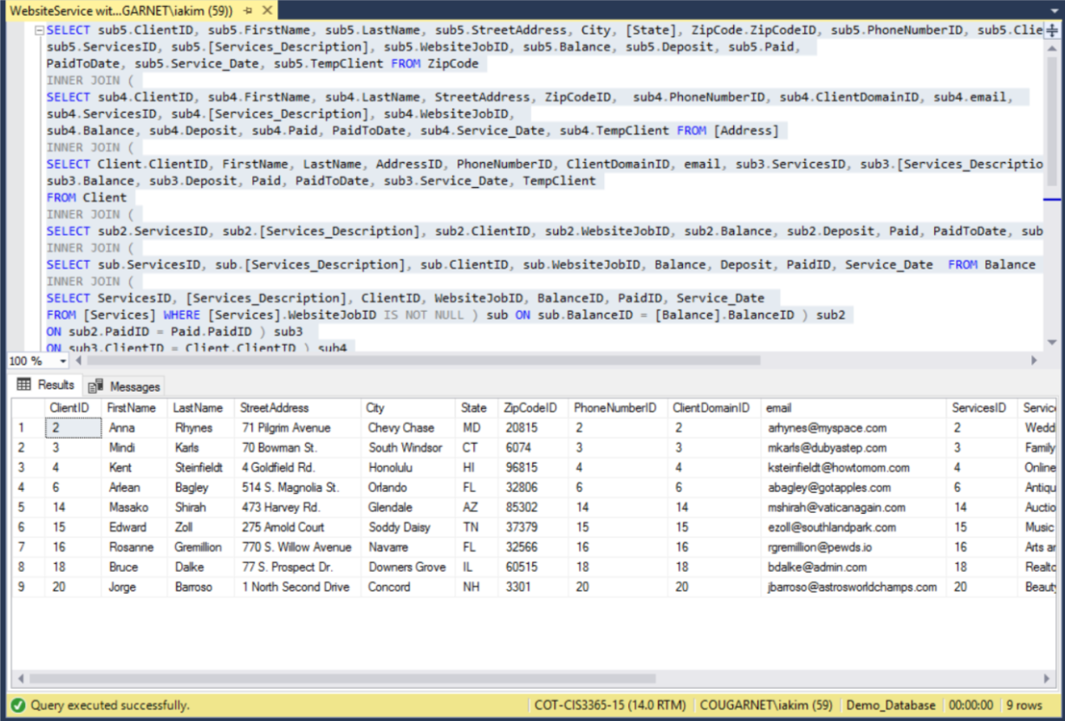

**WebsiteService with Partial Client and Complete Address and Complete Phone Number.sql**

This report shows the website service with the partial client and complete address and complete phone number. Della’s Design needs an easier way to look up current client’s complete address and complete phone numbers in case she needs to contact them for any questions or issues with their current orders. This report will help Della’s Design be able to easily get a list of the clients that are currently receiving services and see the phone number with the area code and the email address and contact them as soon as possible.

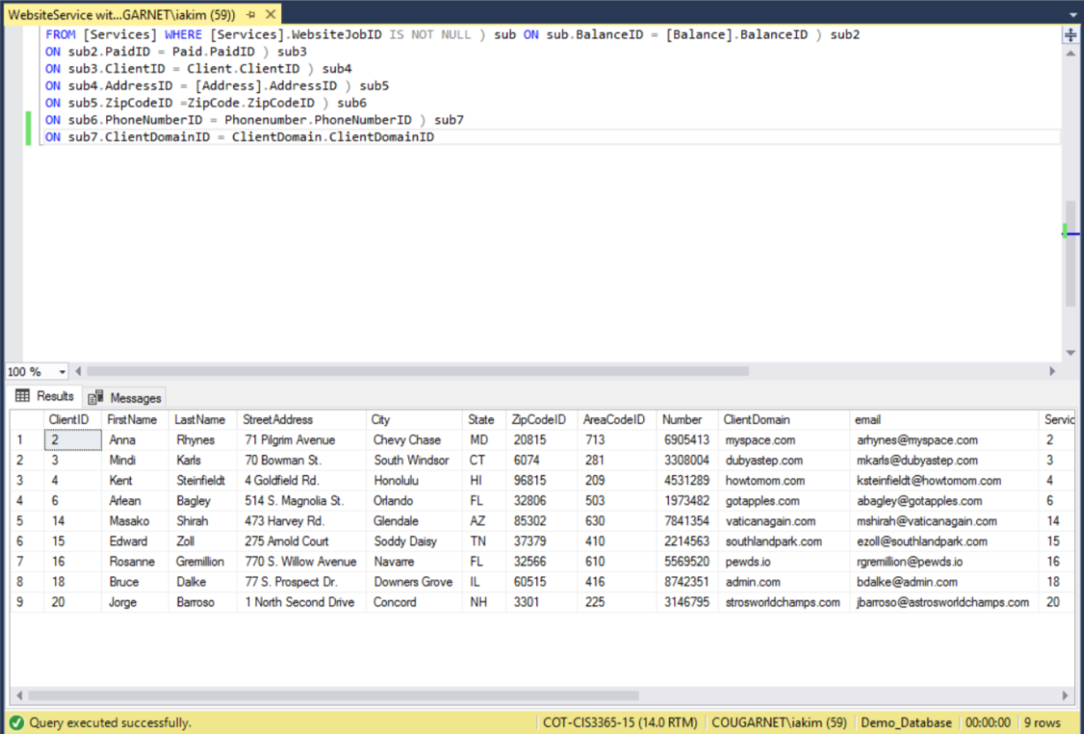

**WebsiteService with Partial Client and Complete Address and Complete Phone Number and Domain.sql**

This query reports shows the website service with partial client, complete address, and complete phone number and domain. According to the requirements that Della’s design has, she sometimes like to search clients email by domain to see how many she has. This report will allow her to see the on what client domain clients have. This will be useful to her because she mostly emails users regarding questions and concerns with the services, this report will be really useful to her needs because can just run this report and be able to get the email address for whatever client she is needing to contact.

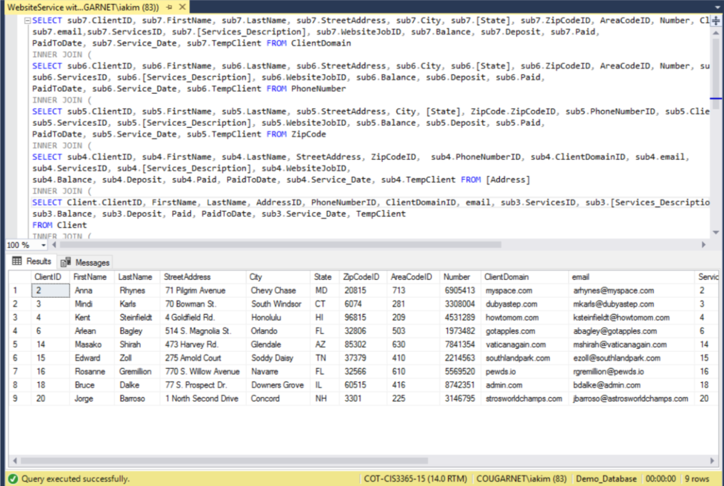

**WebsiteService with Balance and Paid.sql**

This query report shows the website service with the balance and what has currently been paid to Della’s Design. Currently Della’s design uses an excel spreadsheet to keep her client account balance and what currently has been paid, but it is kind of hard to keep switching between spreadsheets in order to get to a certain client. Therefore, we have created this report which she can just run and automatically see the service ID and the description which will the match it to the client ID and will give her a balance of how much the current client owes and how much the client has paid up to date. This will provide her a more concrete way to keep track of her financials so that clients can pay her.

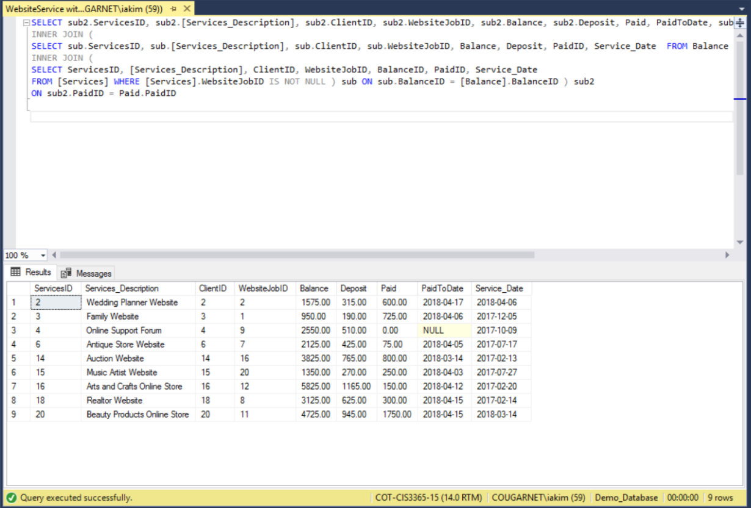

**WebsiteService DONE.sql**

This query report shows the services that have been completed for the client. Currently Della’s Design does not have a way to pull a report so she can see what services have been completed, instead she has to go through a lot of paper in order to see what has been completed, which is not the most efficient way since it is not time efficient. This report will allow her to see which client services have been finished, this way she knows what she does not have to worry about anymore, this report will save her time with customer and employees as she can easily see what has been done and what has not been completed so far.

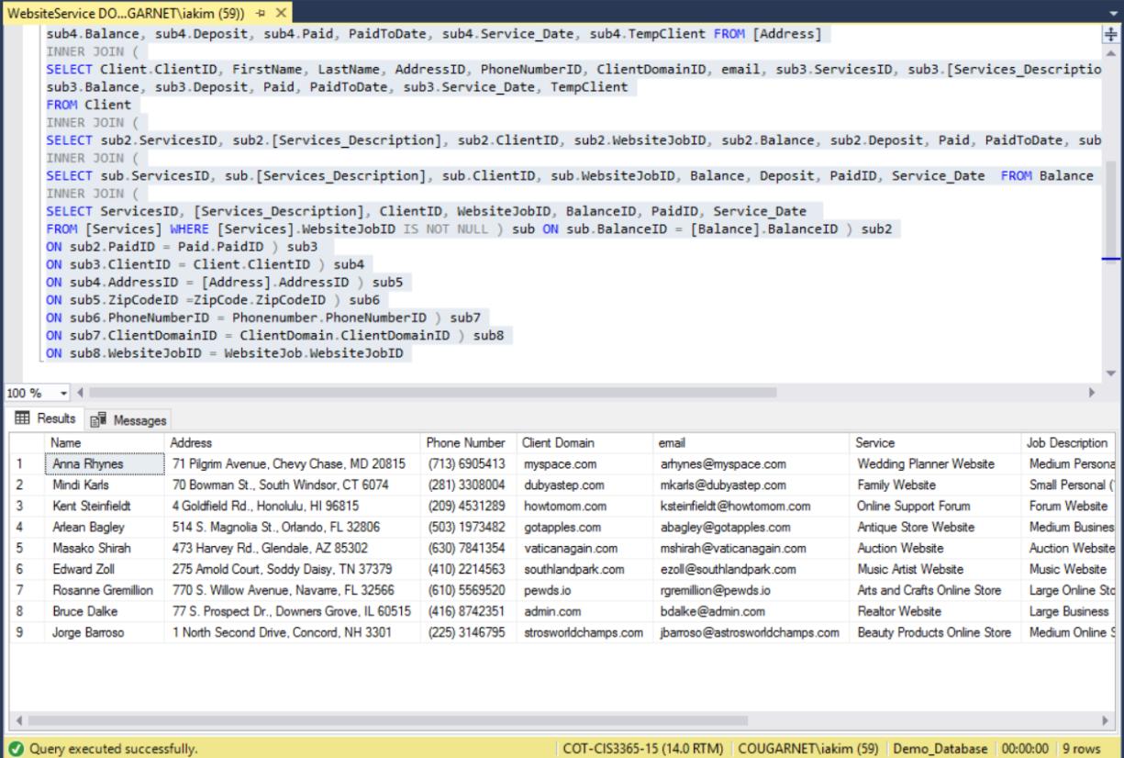

**WebsiteService Beginnings.sql**

This query reports shows the data in which the service was first open. It also gives the clients first name, last name, service description, website job ID, balance ID, paid ID and of course the service date for when the service was first requested. The current system that Della Design currently has does not give her a way to be able to pull a report of when the service started so she is not able to see how much it is taking. This report will allow her to see the service date of the service for when it was entered into the system, which will give her an idea of how long, is taking to complete the service, which she can then show to the client in case any client has questions.

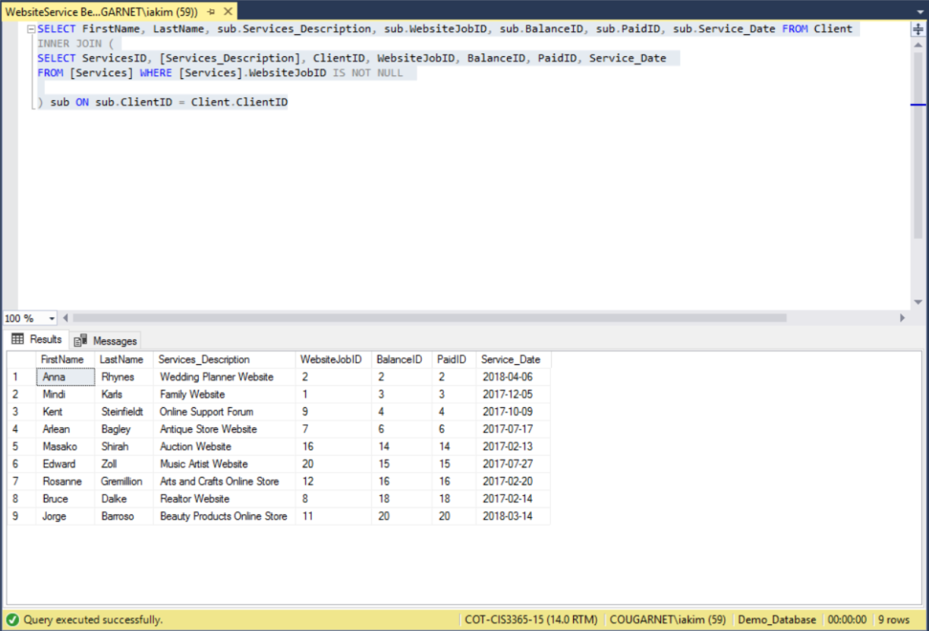

**WebsiteJobServices.sql**

This query report outputs the Website Job Services that Della’s design currently offers to customers. Even though Della’s design has a system to see, what services are offered she wanted to do it digitally. Therefore, this report will allow her to see how many services are currently offered by Della’s Design by outputting the services ID, client ID, service description, website job, and the price. This report also helps her see what she currently has whenever she wants to add more.

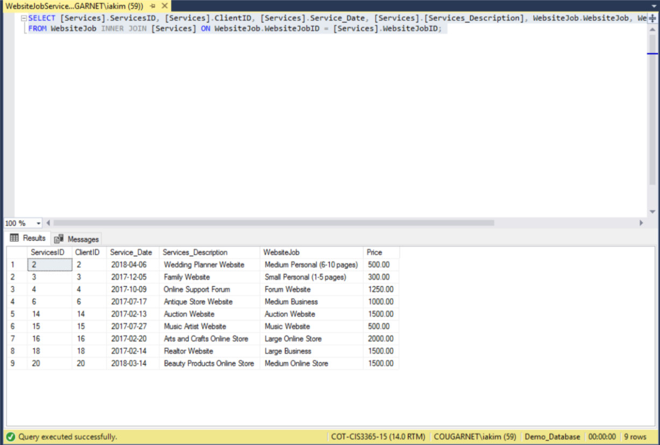

ServiceWithAddons.sql

This query report outputs the current service ID and what addons can be added, as well the price and the quantity. Della’s Design can use this report at any time that either an employee or a customer has questions of what addons can be added to the services and their price. This way she does not have to only have paper prints of it but as well a digital way in her computer which she can just run and show the customer on the spot.

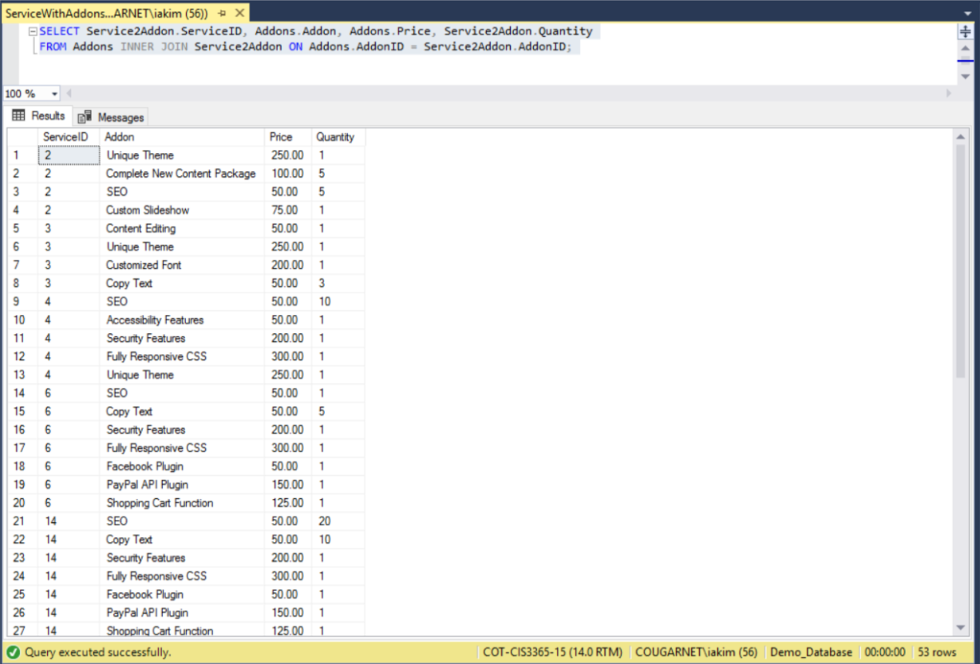

**Search ZipCode.sql**

This report shows a query that can search for a specific zip code. Currently Della’s design does not have a system to easily look up a zip code for specific customer address. This report will help her easily search the city, state, and county for a specific zip code, which will save her the time of having to search through her paper documentation.

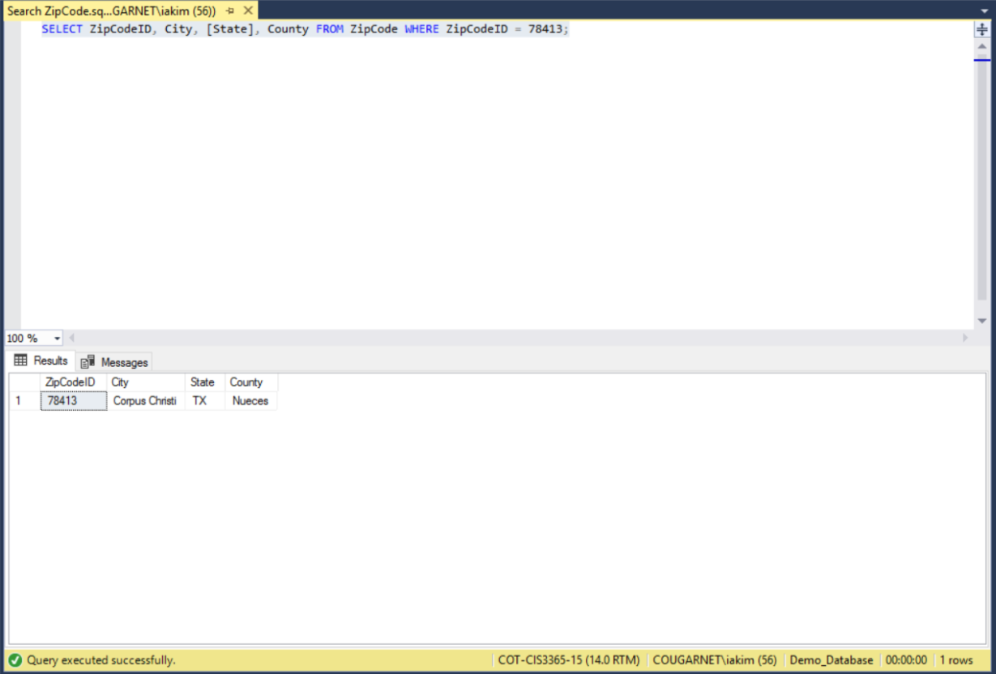

**Function - FindJob**

This query uses a function that request a specific job that shows when the service was done, description, job type, price, and clientID.  Della can use this query to search for when she did a specific job and make the connection to whom she did it for.

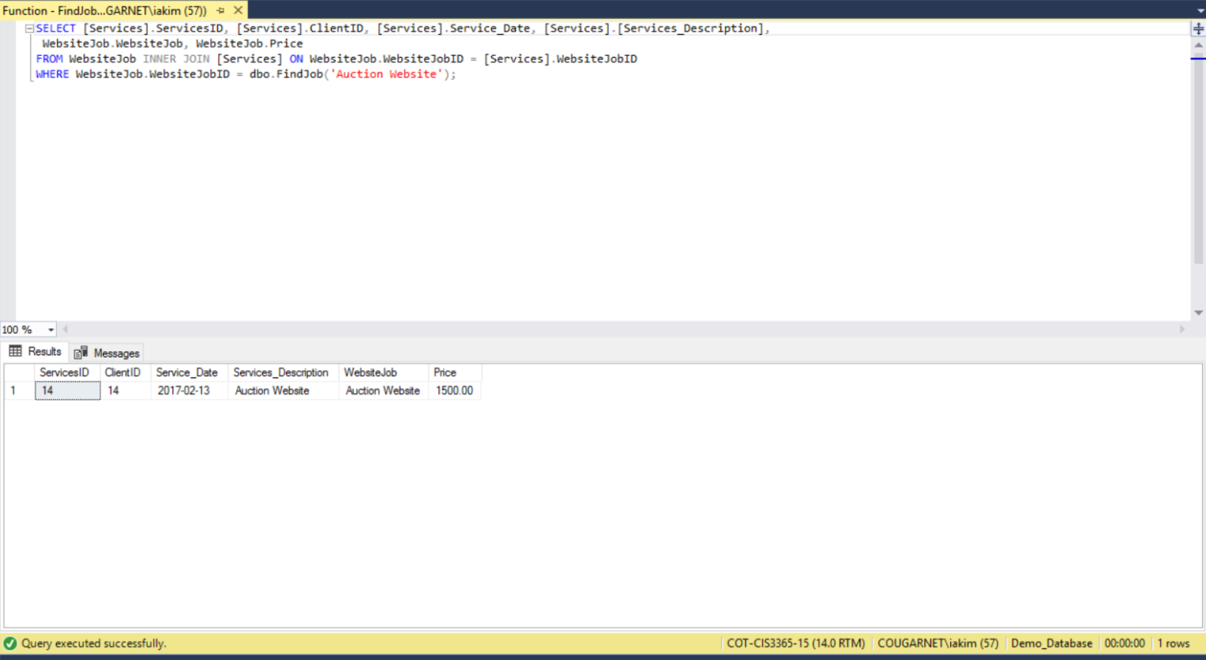

**Function - FindName**

This function calls the first and last name from the client table with other client information.  Della can use this to quickly search a certain client than scrolling through a list of clients.

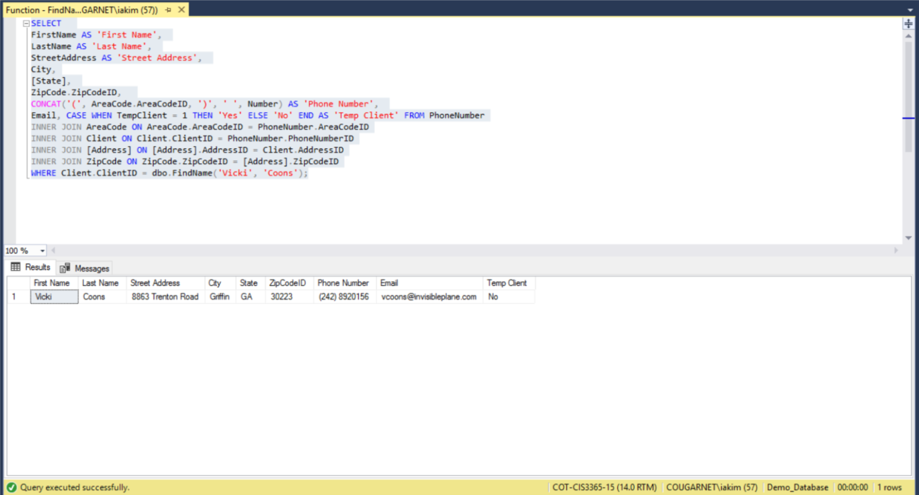

**Function - FindRequirement**

This function associates requirements with the either graphic design or website design job to the clientID and service description.  As shown below, the requirement “new logo” associates with graphic design job to the clientID 11 and the description of that service.  Dellas can use this function to filter services done by the certain requirement of a specific project.

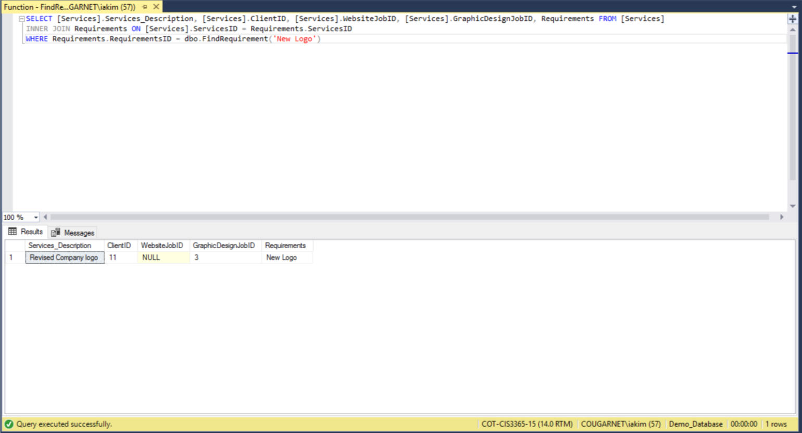

**Function - FindService**

This function uses service description to list all services done under that specific description.  Also list the addon, price, and how many times that service description was done. Della can use this function to filter certain descriptions of a service.

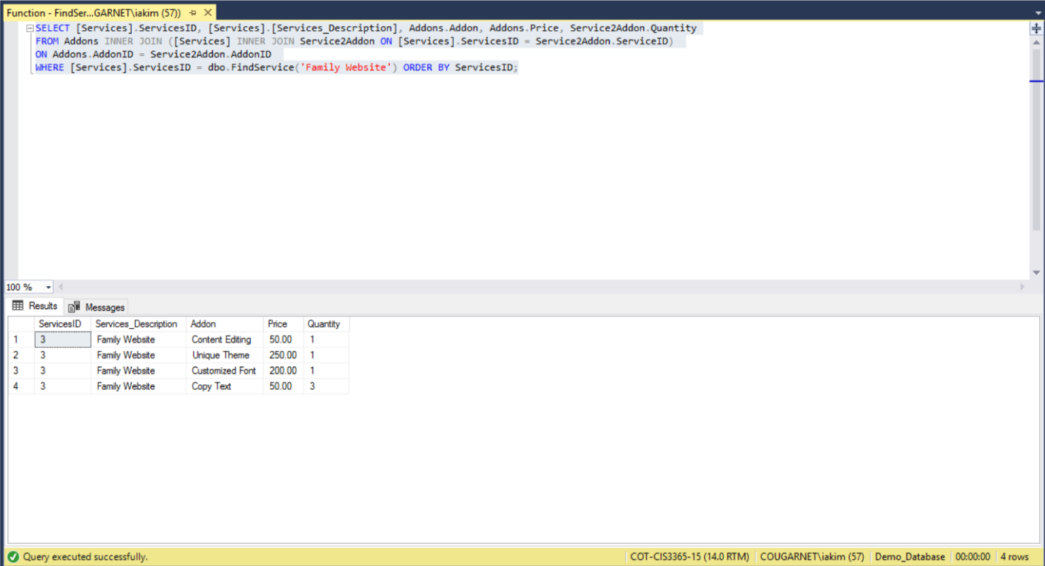

**Function - SearchEmail**

This function filters domain search by username (email) to pull up their domain and password.  Della can use this function to find the domain and password of a client through their email as the email title is their username.

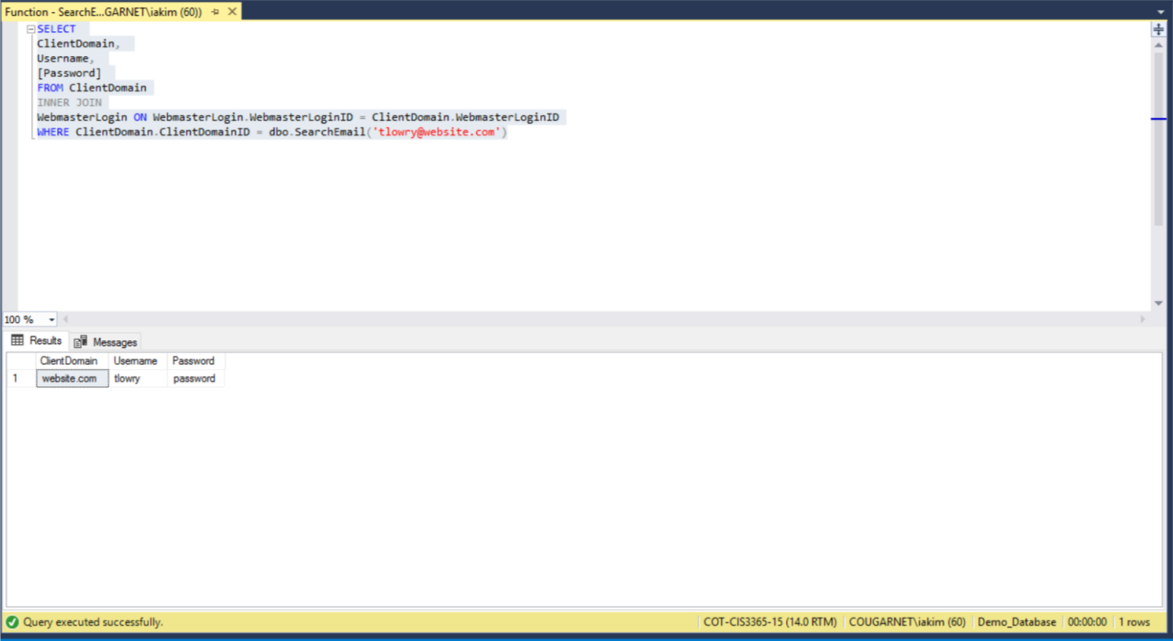

**GraphicDesignService w/ Partial Client, Complete Address, Complete Phone Number**

This query takes the client information and associates it with services, their domainID, graphic design job id, balance, deposit, paid, and dates tables.  This simplifies the previous query by simply applying a filter to less information and associating more ID’s.



## Key decisions

While developing the database, we decided to come up with three tables that would make things easier for Della.  First, we decided to create a TempClient entity that would store client info who have inquired about Della’s services.  If no response is made from them within a week, their information will be deleted automatically. However, if a client decides to further pursue Della services, the information stored in TempClient will be saved for future reference.  This will help differentiate interest from customers. Second, we added a Balance table that would record any unpaid balance (deposit) from Della’s customers and be removed when paid. When the balance is paid, the information goes to PaidToDate table which records when payments were made to Della.  In order for Della to track cost, we implemented a Requirements table that holds information regarding programs used to track cost of those programs as well as added expenses. Lastly, we created a Service table which records description of service, service date, Clientid, WebsiteJobid, and GraphicDesignJobid to track past services. Additionally, the WebmasterLogin associates the Client to a username and password.

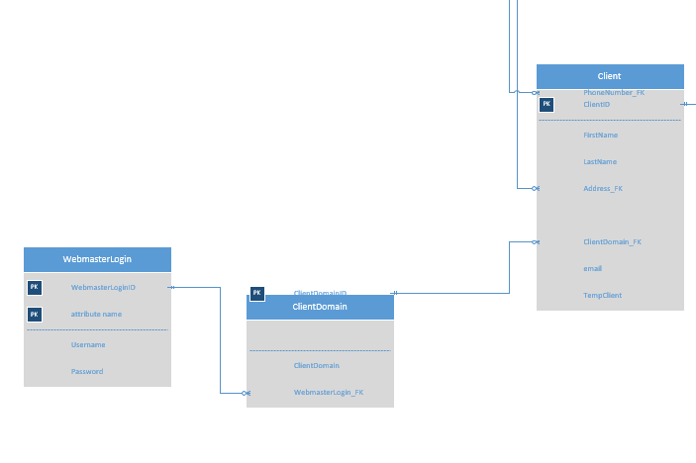

The relationship between WebMasterLogin and ClientDomain is to associate the login credentials with the specified domain associated with the specific client.

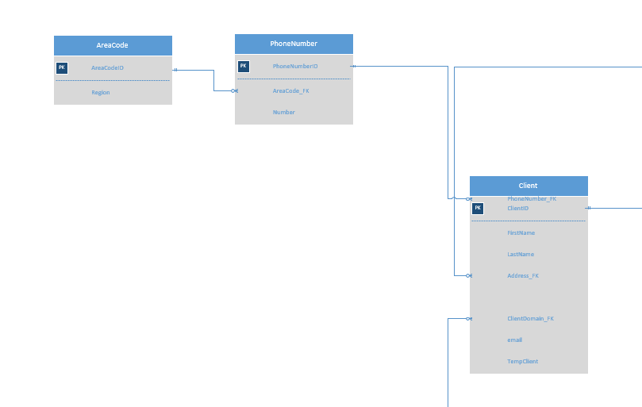

The relationship between client and phone number is provide a contact point for Della to client and the area code is used specify a state from where that phone number is from.

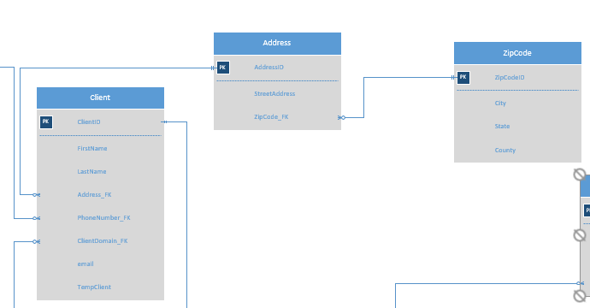

The relationship between client and address and zip code is to associate the client with specified location. Within the client table we added a TempClient which adds clients interested in Della’s Design Solution for service but has not fully committed.

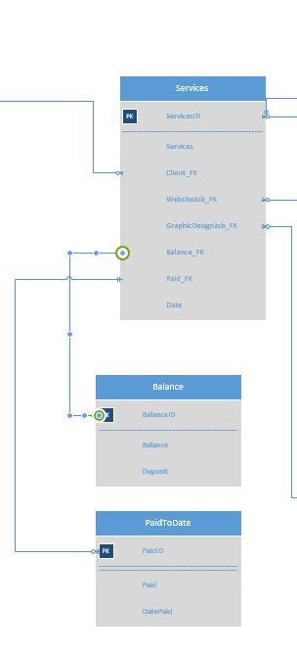

The relationship between services and balance what is to be paid to Della for the specific service. PaidToDate specifies how much has been paid from balance to Della on a service.

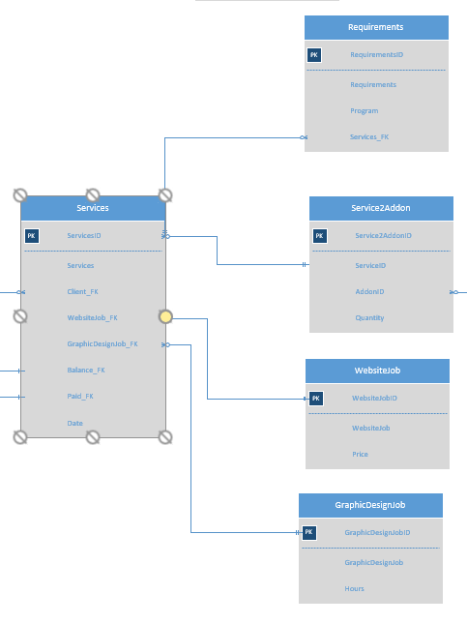

Relation of services to addon, website job, and graphic job are to determine whether it will be set price for the service (website job) or an hourly service (graphic design job).  This also connects back to client by referencing client information to the type of service they requested.

# Testing Process

The testing phase requires multiple areas that need to be tested in order to check for errors and to verify that the highest level of data integrity is achieved. In order to do this, well-structured guidelines need be followed during testing. As a group, we have taken the proper guidelines to verify that the database that we have created is accurate and will work along our Java application to meet our client requirements.

Our database and Java application has been tested through a local SQL server. Our testing phase consisted of two stages, the standalone database and the Java application with the database connection. In order to achieve more accurate results, we decided to test the database first and then the database with the Java application to ensure that it was communicating.

The first phase of testing was our database. The first step that we took to test our database was ensuring that all the tables have been created exactly as it was on the ERD that we created. After we were confident that all the tables were created with the correct attributes, we proceeded to ensure that the data was uploading correctly to the tables with the correct format. After testing that the database connection was successful, we created bulk scripts to load the data from CSV files into the server database. After successfully uploading the data once and we verified that it was accurate and had no nulls, we proceeded to the next step, which was to confirm that our bulk scripts were working correctly. To test our bulk scripts we decided to delete the database and start from the beginning by using the scripts that we had created. When we uploaded the data for a second time, we ensured that it there were no bugs. There were times that as we loaded the data, we realized that our data needed formatting, in this cases we took the opportunity to correct the data and re-uploaded and ensure that it was set to the way we desired. As we compiled our scripts multiple times in the server, we also created different databases within the server to verify the performance of all of our queries and functions. After running, multiple test we came to a point that we had ensure that our database was running smoothly and we were ready to proceed with our Java application.

The second phase consisted of testing our Java application; we started by testing the connection of our database with the GUI. The first step to enable our Java application to communicate with our database was to open a port in the firewall on the server. After we had a successful connection, we tested that our forms were working by entering data into the forms and verifying that the correct data in the correct format was being input into the database and into the correct tables. After verifying that we were successful in using the forms in the Java GUI to enter data into the database through our Java application we proceeded to test our reports. We ran multiple reports to ensure that the output was correct and it matched the client desired. After we finished testing the database and the Java applications and we were, confident with the results we presented our final product to the client to obtain feedback.

        In conclusion, the testing process was long but when we presented the database and Java application to the sponsors, they were impressed with the work that had been done to improve their system. We had some of the users in the shop tested our application and the feedback it was provided was all-positive. As a team, we were successful in the testing stage of our system we verified that every single part of the system was working as expected by our client.

# Project Improvements

The possible improvements made after the completion of our database has been prioritized based on what functions could have benefitted the client the most. The priority of further improvements would be to additional changes to any data formatting and parameters within stored procedures. The GUI can be modified to improve its functionality by updating to a more recent release. There can be a clear field button feature added to a later release of the database to allow for a quicker way for the user to clear fields. After the essential features have been added to the database, a lower priority such as an alert system could be added which would allow the users to be notified of any changes and requirements that may be present. The lowest priority improvement to be designed would be a mobile application for the users to access from their phones.

Any existing data that needs to have its data type modified for better functionality would be a priority for improvement for verification. Any modified parameters within stored procedures that are would need to be verified to check that the statements do not conflict with the database. The necessary updates to the general GUI are essential to the database functionality to the user.

Any new GUI improvements and modifications are not as essential to the database’s function, but can improve the user’s overall experience using the database can help the users to become more proficient with their database. There are low-priority improvements that are not required such as adding a clear button to save the users’ time when clearing multiple fields of data. An alert system for the users for various notifications would improve the communication between the users and the database for any changes to the project to be relayed to the associated user.

The development of a mobile application is a lower priority because the main database needs to be functional and fine-tuned before starting development for another version.

These improvements follow a priority according to what the client and group have agreed upon for the database. Our client and group as for improving the overall functionality of the database with these features have prioritized the group and user hold meetings for discussions to describe.

**Priority**

1. Data Formatting
2. Parameters within stored procedures
3. General GUI updates
4. GUI modifications
5. Clear button
6. Alert system
7. Mobile application

# Project Database Maintenance Issues

With the implementation of the database system for Della’s Design Solutions, there is a need to update the functionality of the data in the system while maintaining the integrity of the database. The following will keep the system integrity and ensure that the database has the ability to have data cleanup, backups, restores, and be able to retrieve date.  The database should be able to create, alter, bulk insert, and query.

The data within the SQL will need to be tested regularly to verify its integrity and functionality.  The relationships will need to be regularly validated and have the connections between the database and GUI verified to ensure that the functionality is correct. The queries will need to be tested and resolved of any errors then rewritten and reloaded. Any unexpected null values will need to be corrected and have the appropriate values input.  Any changes should be rewritten and reloaded into the database then have the data reformatted to ensure that the referential integrity is still maintained, and additionally make sure that the database is still functional and connected to the GUI. Referential integrity should be also be checked

In addition to the testing steps, the maintenance process consists of backing up data, checking the database integrity, and reducing the size of the database when possible. There will be a regular backup of the database during the regular maintenance with the option to restore any backups selected. During maintenance, the reduction of database files and logs where applicable will streamline the application and improve the speed of the database.

The maintenance process requires the regular testing of various features of the database and the maintenance steps to ensure that the database is still functional and its lifespan prolonged for future use.

**List of testing problems:**

1. Storage space Issues - Oracle files keep growing as usage grows, so you need to monitor physical space as the database files to care if space is available or not.

2.  Performance issues  - degrading is also a major issue, reasons; the more the clients uses the application you have to keep getting feedback from users and updating your application sometimes to meet up with the varying demands.

3.Cost of Maintenance - the recurring cost of maintaining the database

5. Need for frequent updates -  to maintain the security and functionality

6. Network outages -  When a system is down, database performance obviously is at its worst. Outages can be caused by database issues such as running out of storage space due to increasing data volumes.

**List of testing steps:**

1. Test data within SQL
2. Validate relationships
3. Correct functionality
4. Check connection between database and GUI
5. Testing the data
6. Resolving errors
7. Using waves to load data
8. Testing queries
9. Unexpected null values
10. Rewrite and reload
11. Testing the GUI
12. Check the connection
13. Reformat the data
14. Compiled the create, alter, bulk insert scripts, and queries
15. Tested for referential integrity
16. Revised code and data
17. Test again with full data uploaded
18. Connect SQL Server to Java GUI

**List of maintenance steps:**

1. We perform a full backup of the system on an automated schedule.
2. check database integrity by using the created documentation on how to restore the database back to the original state.
3. Shrink database to reduces the size of the database’s data and log files in order to increase efficiency of the database

# Lessons Learned

**Not Everything is Possible**

Since the early stages of our project, many changes were made to the overall project. There were many features that we thought were a possibility to complete for the client but after the analysis of the time constraints and the requirements of the work that it would take to complete; we needed to adjust our project. Our group realized that everything we had planned to do in the beginning not going to be possible to complete. The lesson learned from this adjustment is to look at things in a realistic way and expect to be not able to promise things that are not possible to complete.

**Time restraint**

A timeline is important for every project that is established to make sure that the project is scheduled for completion in the expected time frame that is agreed with the client. However, this is not always the case, as things can change at any stage of the project. As a team we got too comfortable that we could finish everything since we were ahead of everything which lead to procrastination in many areas of the project. As a result, we ended up doing last minute modification to the documentation right before the project was due to ensure that all the documents were formatted and completed to turn in. However, this semester we were able to be more organized in that sense. As a team we found times that we were all off from work and other classes to meet as a group and work on the database, GUI, and documentation. Assignments were distributed to each team member to be completed before the next meeting. By using this method, we were able to be more organized this semester and made sure that assignments were done on time and were corrected by the rest of the group if needed.

**Keep the scope small**

As stated in “Not everything is possible”, we had to shrink the scope of the project with the client because there were so many things that were not going to be possible to complete in the time restraint. As we brought the issue to the client and talked, we had the client discuss what were the most important parts of her system that she would like to be improved the most. As a team we learned that the best way is to start small and not promise a vast amount of things because many times due to lack amount of resources and time restraint not everything is possible.

**Hope for the best, expect the worst**

Our group would often assume things were going to go smoothly when they did not. As we welcome new team members to the group that were not as familiar with the project as the members who transitions from last year we realized the best would not always be possible. Although new team members had the chance to look over the data to understand the purpose of the project, it was still a bit hard for those new team members to understand it easily. Not only did we have issues with new team members understanding the project, but as a group we also had issues with meetings since everyone had their own schedule of work and classes. It was hard to come across times that we all were available.

**The client might not be able to make decisions**

When we first talked to our client there were many things that needed to be addressed, but as we began to build the project we realized that there were many things that could not make the final version. As a result we had to cut some of the requirements. In order to do this we had to schedule a meeting with her and our group to discuss what features we thought would be best to keep. As a result we learned that sometimes the client needs to be realistic and as a group decisions need to be made in order to meet the time frame for the project.

**Update Data Dictionary Constantly**

One of the biggest mistakes that we faced while creating the database was not keeping the data dictionary up to date as we made changes to the database. This caused a lot of problems towards the end of development since the dictionary was not matching with the table information in the SQL database. This caused confusion for our team member in charge if the data dictionary and it also wasted time that we could have allocated to other documentation. The most important thing we learned from this was that is important to update the data dictionary as you build and make changes to the database that way everything is synced.

# Project Summary

In the current system Della’s Design Solutions does not have a system in place that is efficient enough for the clients and the owner. Currently Della’s Design Solutions manually inputs requests and related prices into a word document. The prices and calculated down payments are done manually. The current system does not provide storage to organize the data of different projects that are being worked on for different clients which turn into a waste of time, resources, and money. Currently the system has unlinked data which makes it potentially vulnerable to the loss of data due to the lack of backups of important clients and company data. Our group’s goal is to create a new system that can input client info and their project scope to generate invoices, determine the service prices, calculate deposits for projects, and keep track of hours. The application that we are proposing to Della’s Design Solution will be a SQL database in the back end where client information and project requests, services, additional costs and various calculations will be performed based on the parameters of the project scope.  The Java application and the SQL database will provide Della’s Design an opportunity to be more efficient, reduce data redundancy, and provide better access to client data for quicker, more efficient results

# References

“Execute User-Defined Functions.” *Microsoft TechNet*, technet.microsoft.com/en-us/library/ms175562(v=sql.110).aspx.

Archiveddocs. “Table-Valued User-Defined Functions.” *Microsoft Docs*, docs.microsoft.com/en-us/previous-versions/sql/sql-server-2008-r2/ms191165(v=sql.105).

Coronel, Carlos, and Steven Morris. *Database Systems: Design, Implementation, and Management*. Cengage Learning, 2017.

Rothja. “Create User-Defined Functions (Database Engine).” *Microsoft Docs*, docs.microsoft.com/en-us/sql/relational-databases/user-defined-functions/create-user-defined-functions-database-engine?view=sql-server-2017.

Seifallah. “Seifallah/Dynamic-TableView--Java-Fx-2.0-.” *GitHub*, github.com/seifallah/Dynamic-TableView--Java-Fx-2.0-/blob/master/DynamicTable.java.

# Appendices

**Brooke Schapiro**

*ClientAddress*  
  
ClientAddress query results all addresses associated with clients.  Reason why our client would want to use this is to specify a certain address for a client.   
  
 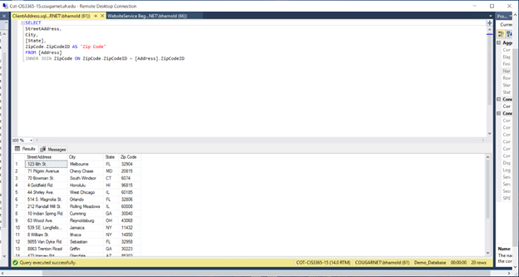

*Function - SearchEmail*

This function filters domain search by username (email) to pull up their domain and password.  Della can use this function to find the domain and password of a client through their email as the email title is their username.

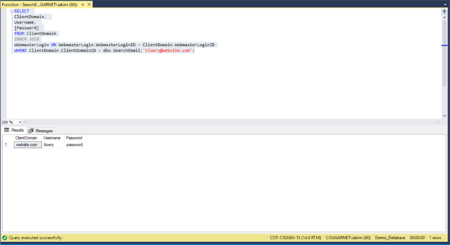

*Search GraphicDesignService*

This query filters the first and last name of the client and what graphic design service was completed for them.  Also shows the balance, deposit, amount paid towards balance and dates of when payment was made and services done.  Della can use this to find the information of a past service to a specific client.

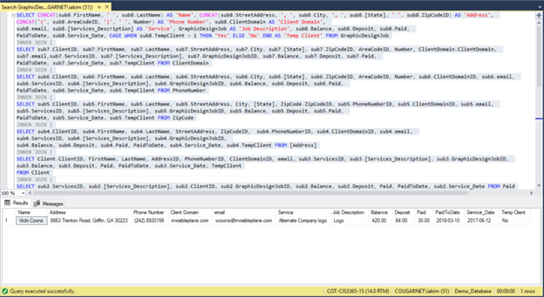

*WebsiteService with Partial Client and Complete Address and Complete Phone Number.sql*

This report shows the website service with the partial client and complete address and complete phone number. Della’s Design needs an easier way to look up current client’s complete address and complete phone numbers in case she needs to contact them for any questions or issues with their current orders. This report will help Della’s Design be able to easily get a list of the clients that are currently receiving services and see the phone number with the area code and the email address and contact them as soon as possible.

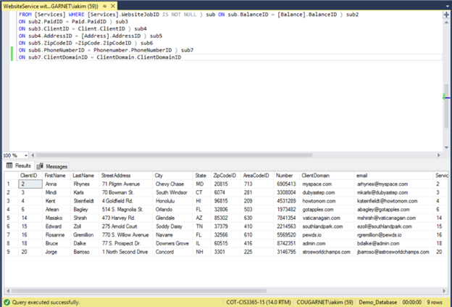

*WebsiteService with Partial Client and Partial Address.sql*

This query report shows the website service with the partial client and the partial address. Della’s Design likes t sometimes just search partial parts for the cline and the address to make it a short list. In this report only the first name, last name, street address, and zip code are generated which gives her a shorter description for customer information which will fulfill this requirement that she has asked to complete.

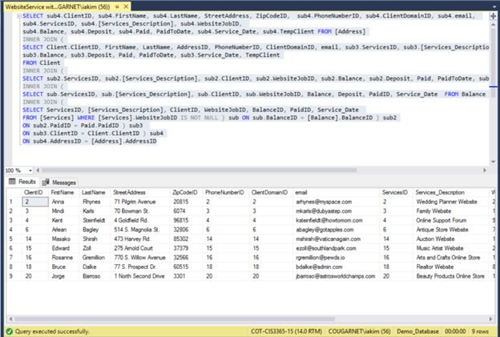

*WebsiteServiceWithAddon.sql*

This query report takes the addon price with the quantity of addons that a client desires and multiplies it, it is then stored in “AddonTotal”. When this report is running it will output the Service ID, name of the service, and it will give the total of the addon.  Della’s Design currently does not have a way to keep track of addons that are added to services in an organized way that will help her keep track and give an accurate total to the client. This report will satisfy her requirement to be able to keep track of what addons are being added to which outstanding orders and the prices to be able to invoice the client.

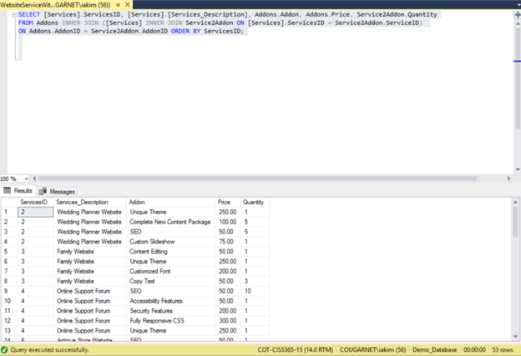

**Bryan Arnold**

*WebsiteServiceWithAddon – Totaled.sql*



Description:

This query report shows the Website Service with add on with the quantity calculated. Della’s designed currently writes people add on requests on paper and the calculated the total user a calculator and writes it back in which is time consuming and is not able to tell customer their total right away. This report will help her get rid of that issue but allowing her to run a report of the addons and it will not only give her total of the addons that have been added by the customer but it will also give her a total of the addons.

*CleanWebsite DONE.sql*

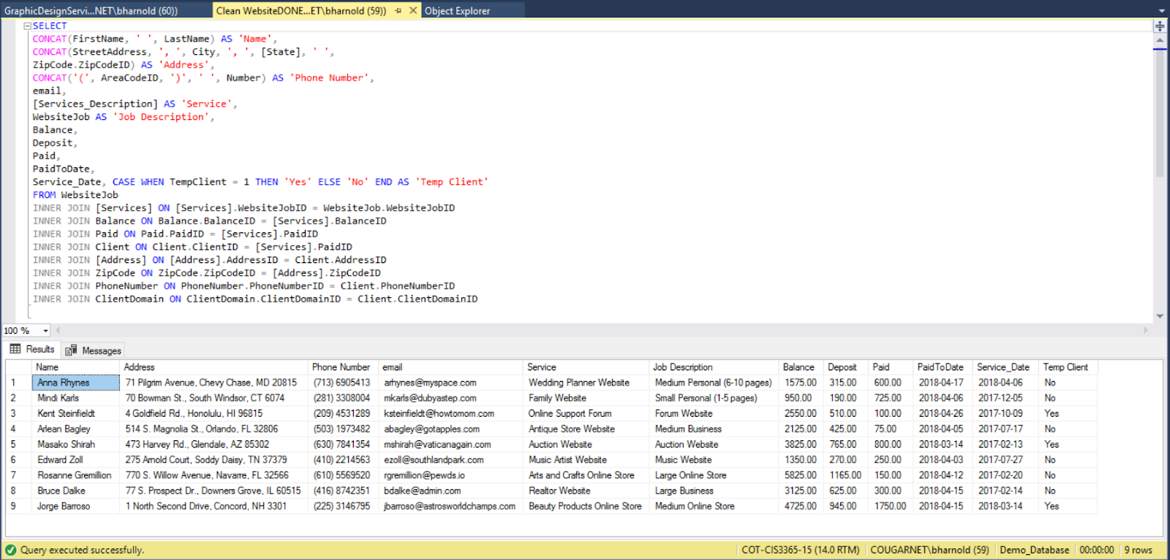

Description:

This Query pulls together, important client data and combines it with Website Services w/addons. This creates a complete view in terms of our ERD where client is combined with their services.

*Function - FindJob.sql*

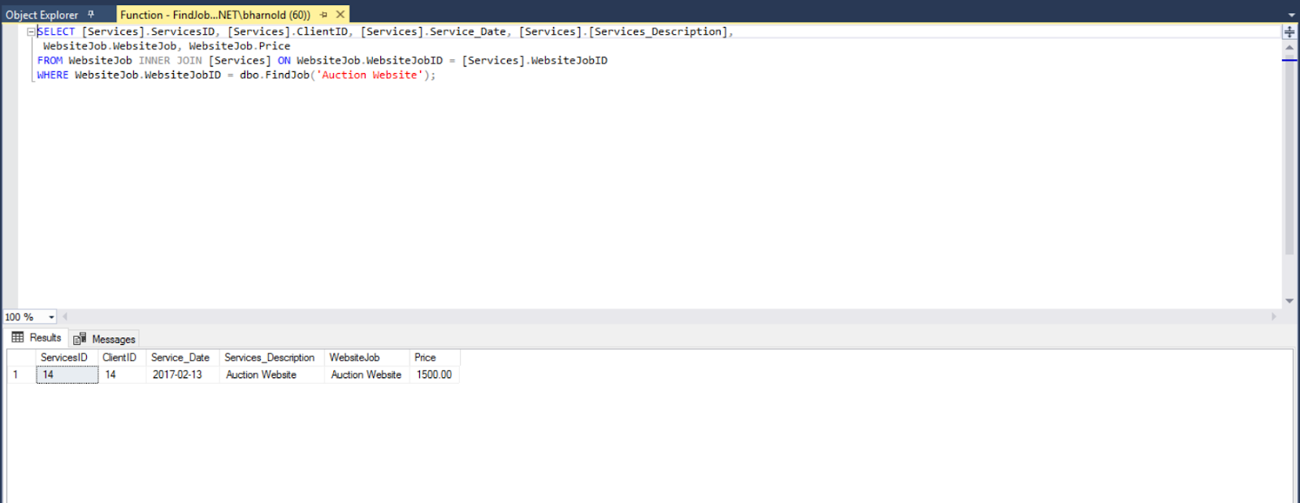

Description:

This function pulls a JobID from The WebsiteJob and uses it as a search parameter to find all services with that job now

*GraphicDesignServiceDone.sql*

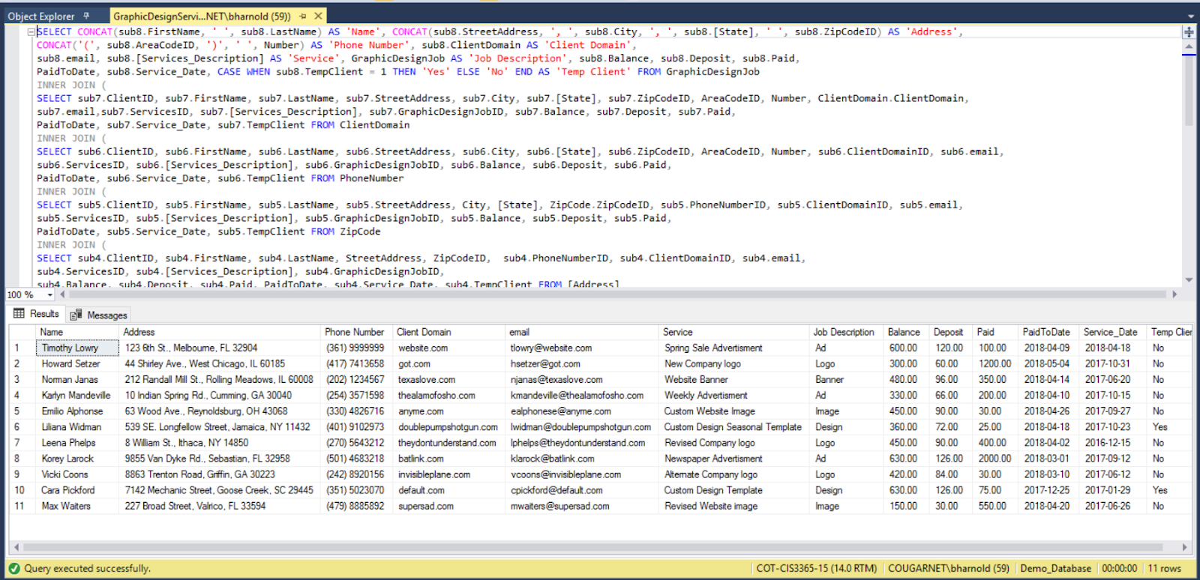

Description:

This query pulls all client information and joins it with GraphicDesignServices this creates a full client view with their services.

*GraphicDesignService with Partial Client and Complete Address.sql*

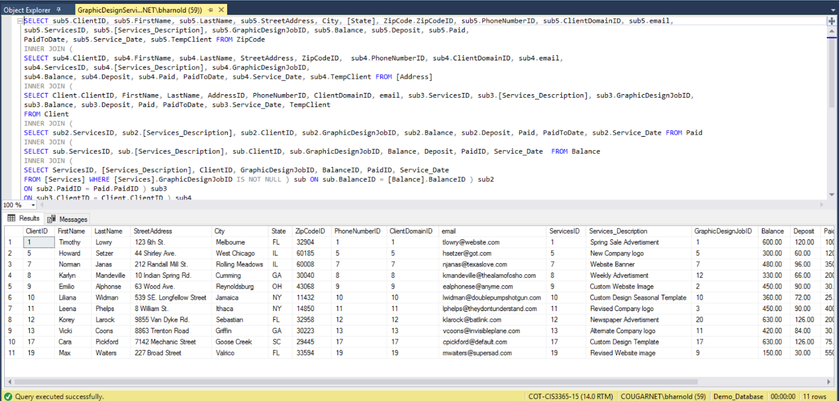

Description:

This Query pulls Part of the Client information and combines it with the complete address to form a full address with a client name.

*Search Client.sql*

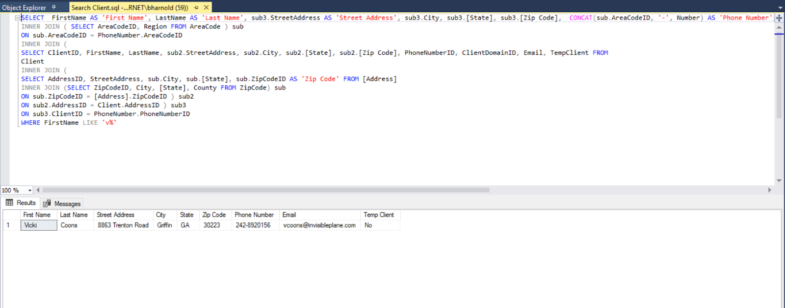

Description:

Search a full client table with a FirstName as a parameter and select all clients that fit that criteria.

**Wilfredo Sandoval**

*Function – FindAddon*  
  
 Description:  
  
The function that was created is called FindAddon. What this function does is searched for different services and addons. This gives you the ServiceID, Service Description, addon, Price, and Quantity. My specific function searches for the SEO add on.

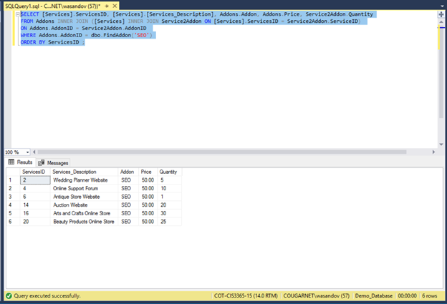

*GraphicDesignServices with Partial Client and Complete Address and Complete Phone Number and Domain*

Description:

This query report outputs the graphic design services with partial client, complete address, complete phone number and domain. Currently Della’s design does not have a way to pull a report to show her complete information about the client. This query will allow her to be able to pull up a report of the client that will show the complete address, phone number, and the domain. This will help her save time when she does searches for customers.

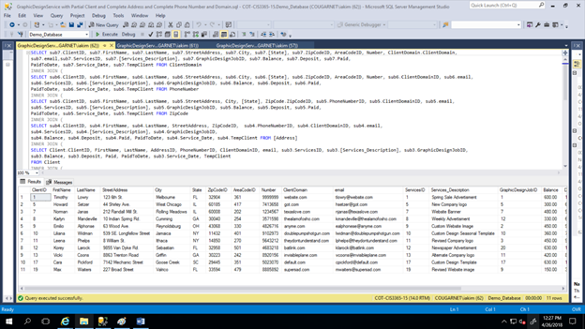

*Search AddonUsed*

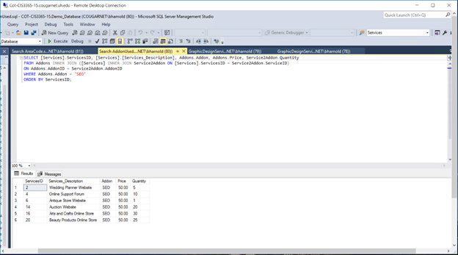

Description:

This query report uses my search function to search for outputs of the SEO addon that is being used. Currently Della’s Design does not have a system that that searches for specific addons. This function and query will help her search for this addon easier. This addon is really important because most of the clients look for it. Therefore, it will be useful for her to use.

*Search AreaCode*

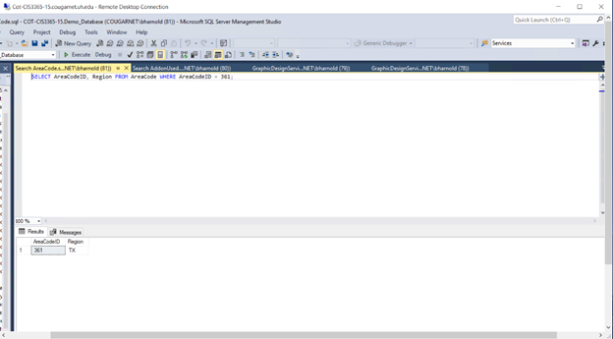

Description:

This Query report results in the search of which area code belongs to which state.  Della currently does not have a way to search for area codes that belongs to states. This is useful to her and will help her day to day operations when she invoices to customers.

*WebsiteService with Partial Client and Complete Address.sql*

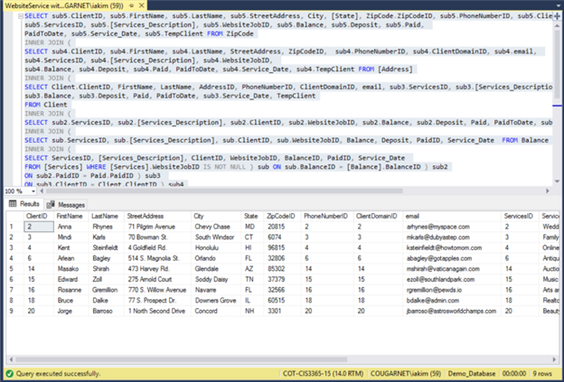

Description:

This query reports represents the website service with the partial client and the complete address for that specific client. Currently Della’s Design keeps all her customer data in paper which are stored in file cabinets and every time she wants to access this information she has to go through tons of papers to get to the specific client that she is looking for. This report will help Della’s design be able to pull a report of all the current clients that services are being provided to and she will be able to tell the clients first name, last name, and address as well as the email address.

*WebsiteService with Partial Client.sql*

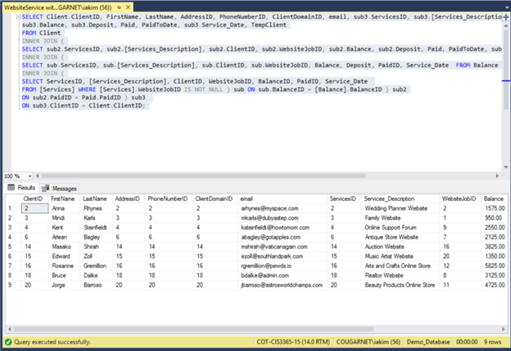

Description:

This query report shows the website service with the partial client. Since one of Della’s Design requirements was to be able to pull up the client and be able to match it to the website service that the client has currently requested. This report will help Della’s Design meet this requirement by being able to run a report that will pull up the data of the client and service by ID. It will also show the client first name, last name, and phone number. When it comes to the service, it will match it to the client ID and she will be able to see the service description and the balance that the client owes.

**Floyd Brown**

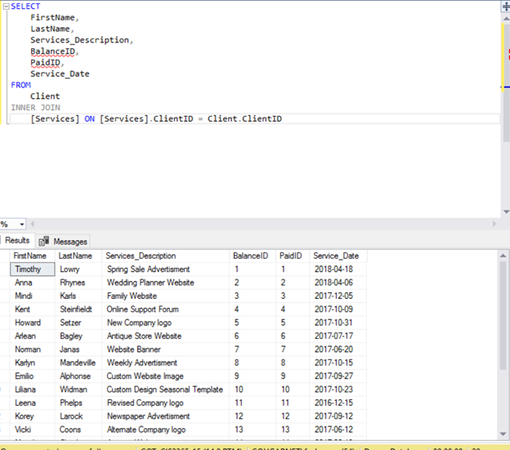

Description:

This was my first query that retrieved all the relevant information for the customer in which we can use to see what customer needs what material they use for service descry

---

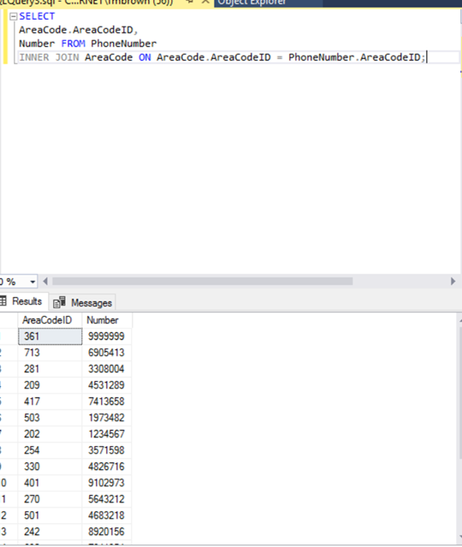

Description:

This was a basic query call to retrieve the phone number so we can call the customer and let them know that their order is ready.

---

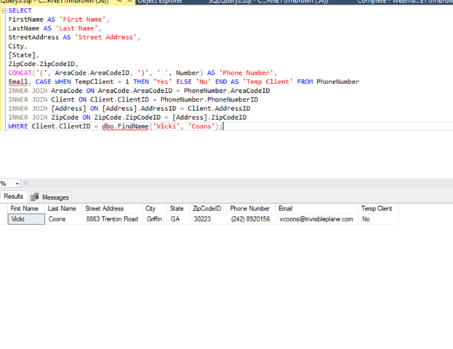

Description:

Pulls a relevant customer from a select query which combines a phone number

This was a query using a subquery concatting the customers phone number to give a full description of who our customer is and if they are temporary or consistent customer

---

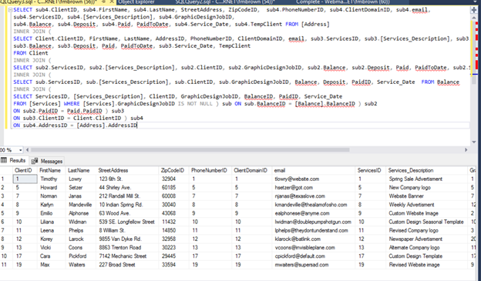

Description:

This is select query for multiple tables to pull all relevant information that brings up all the subtotals and totals which uses a sub query.

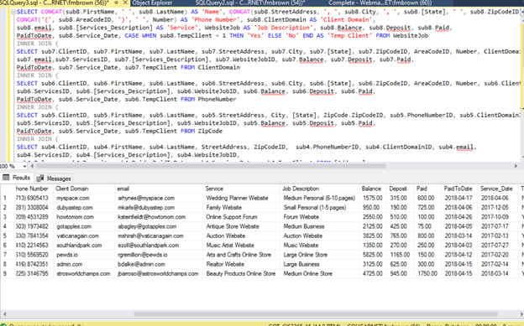

Description:

This is the query for combining balance and deposit for the services

---

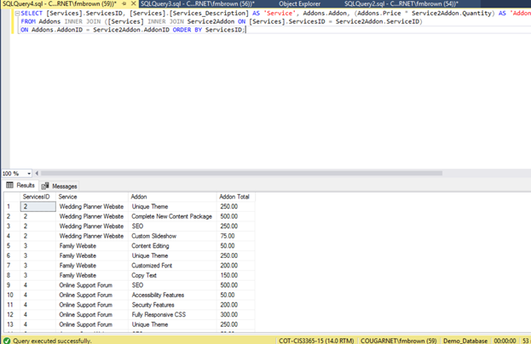

Description:

This is my function query that calculates add ons

**IL-Hwan Kim (Andy)**

*Complete Client*

Results in all client information being shown.  Deciphers between a temp client and actual client as well list all information associated with that client.  She can use this query to see how many clients she has as well as potential clients.

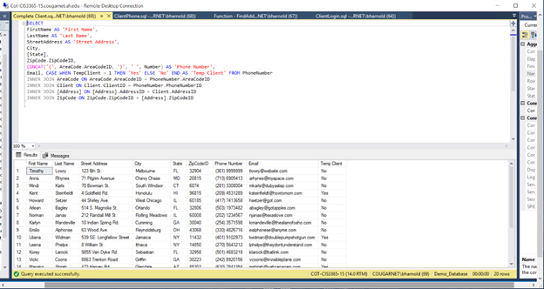

Function - FindRequirement

This function associates requirements with the either graphic design or website design job to the clientID and service description.  As shown below, the requirement “new logo” associates with graphic design job to the clientID 11 and the description of that service.  Della’s can use this function to filter services done by the certain requirement of a specific project.



*GraphicDesignService with BALANCE AND PAID*

This query shows when the client made a payment towards a balance and when the service began.  Della can use this to determine which clients have paid either deposit or full amount towards balance in association with service date to paid date.



*GraphicDesignService w/ Partial Client, Complete Address, Complete Phone Number*

This query takes the client information and associates it with services, their domainID, graphic design job id, balance, deposit, paid, and dates tables.  This simplifies the previous query by simply applying a filter to less information and associating more ID’s.



*WebsiteService with Balance and Paid.sql*

This query report shows the website service with the balance and what has currently been paid to Della’s Design. Currently Della’s design uses an excel spreadsheet to keep her client account balance and what currently has been paid, but it is kind of hard to keep switching between spreadsheets in order to get to a certain client. Therefore, we have created this report which she can just run and automatically see the service ID and the description which will the match it to the client ID and will give her a balance of how much the current client owes and how much the client has paid up to date. This will provide her a more concrete way to keep track of her financials so that clients can pay her.



**Barret Margin**

*ClientLogin*

ClientLogin results in matching the domain with the specific username and password of the client.  This will allow Della to relate her clients to their domain with login credentials.



*Function - FindDomain*

Filters domain with login credentials based on domain of choice.  Della can use this to find a specific domain for a certain client.



GraphicDesignService Beginning

This query results association between client information, services, balance, and paid.  Based off of client information, it will result in the description of the service, job type, balance, paid, and when the service took place. Della can use this query to see past services she has done.



*Search ZipCode.sql*

This report shows a query that can search for a specific zip code. Currently Della’s design does not have a system to easily look up a zip code for specific customer address. This report will help her easily search the city, state, and county for a specific zip code, which will save her the time of having to search through her paper documentation.



*WebsiteService with Partial Client and Complete Address and Complete Phone Number.sql*

This report shows the website service with the partial client and complete address and complete phone number. Della’s Design needs an easier way to look up current client’s complete address and complete phone numbers in case she needs to contact them for any questions or issues with their current orders. This report will help Della’s Design be able to easily get a list of the clients that are currently receiving services and see the phone number with the area code and the email address and contact them as soon as possible.



**Vivian Salako**

*Function - FindService*

This function uses service description to list all services done under that specific description.  Also list the addon, price, and how many times that service description was done. Della can use this function to filter certain descriptions of a service.



*GraphicDesignService w/ Partial Client*

Results in client first and last name associated with the IDs of everything else.  Purpose of this query is providing less information and give Della only the information she needs.



*ServiceWithAddons.sql*

This query report outputs the current service ID and what addons can be added, as well the price and the quantity. Della’s Design can use this report at any time that either an employee or a customer has questions of what addons can be added to the services and their price. This way she does not have to only have paper prints of it but as well a digital way in her computer which she can just run and show the customer on the spot.



*WebsiteJobServices.sql*

This query report outputs the Website Job Services that Della’s design currently offers to customers. Even though Della’s design has a system to see, what services are offered she wanted to do it digitally. Therefore, this report will allow her to see how many services are currently offered by Della’s Design by outputting the services ID, client ID, service description, website job, and the price. This report also helps her see what she currently has whenever she wants to add more.



*WebsiteService Beginnings.sql*

This query reports shows the data in which the service was first open. It also gives the clients first name, last name, service description, website job ID, balance ID, paid ID and of course the service date for when the service was first requested. The current system that Della Design currently has does not give her a way to be able to pull a report of when the service started so she is not able to see how much it is taking. This report will allow her to see the service date of the service for when it was entered into the system, which will give her an idea of how long, is taking to complete the service, which she can then show to the client in case any client has questions.

